**1.**[**What is Node.js?**](https://www.geeksforgeeks.org/introduction-to-node-js/)

[Node.js](https://www.geeksforgeeks.org/node-js-introduction/) is an [open-source](https://www.simplilearn.com/tutorials/nodejs-tutorial/what-is-nodejs), cross-platform [JavaScript](https://www.simplilearn.com/tutorials/javascript-tutorial/introduction-to-javascript) runtime environment to executing JavaScript code outside the browser.

It is normally used to build the backend/server-side web application and is highly scalable.

It is built on **Chrome’s V8 JavaScript engine** for executing JavaScript code outside of a browser.

It provides an event-driven, non-blocking (asynchronous) I/O, and cross-platform runtime environment for building highly scalable server-side applications using JavaScript.

OR

[Node.js](https://www.geeksforgeeks.org/node-js-introduction/) is an [open-source](https://www.simplilearn.com/tutorials/nodejs-tutorial/what-is-nodejs), cross-platform [JavaScript](https://www.simplilearn.com/tutorials/javascript-tutorial/introduction-to-javascript) runtime environment which is built on **Chrome’s V8 JavaScript engine** for executing JavaScript code outside of a browser.

**What is Run Time Environment**

It is an environment where your program will be executed.

It act as small operating systems and provide all the functionality necessary for a program to run.

Some functionality are I/O operations, memory management etc

**2.**[**What is the difference between Node.js and JavaScript?**](https://www.geeksforgeeks.org/difference-between-node-js-and-javascript/)

JavaScript is a scripting language whereas Node.js is an engine that provides the runtime environment to run JavaScript code.

Here we have [difference table between Node.js and JavaScript](https://www.geeksforgeeks.org/difference-between-node-js-and-javascript/)

| [Node.js](https://www.geeksforgeeks.org/node-js-introduction/) | [JavaScript](https://www.geeksforgeeks.org/introduction-to-javascript/) |
| --- | --- |
| Server-side runtime environment | Client-side scripting language |
| Allows running JavaScript code on server | Primarily used for web development |
| Built on Chrome’s V8 JavaScript engine | Runs in a web browser’s JavaScript engine |
| Enables building scalable network applications | Executes code within a browser environment |
| Provides access to file system and network resources | Limited to browser APIs and capabilities |
| Supports event-driven, non-blocking I/O operations | Executes in a single-threaded event loop |
| Used for building backend APIs, servers, and applications | Utilized for creating interactive web pages and client-side logic |

**Q3: What are the benefits of using Node.js? ☆☆**

**Answer:** Following are main benefits of using Node.js

* **Aynchronous and Event Driven** - All APIs of Node.js library are aynchronous that is non-blocking. It essentially means a Node.js based server never waits for a API to return data. Server moves to next API after calling it and a notification mechanism of Events of Node.js helps server to get response from the previous API call.
* **Very Fast** - Being built on Google Chrome's V8 JavaScript Engine, Node.js library is very fast in code execution.
* **Single Threaded but highly Scalable** - Node.js uses a single threaded model with event looping. Event mechanism helps server to respond in a non-bloking ways and makes server highly scalable as opposed to traditional servers which create limited threads to handle requests. Node.js uses a single threaded program and same program can services much larger number of requests than traditional server like Apache HTTP Server.
* **No Buffering** - Node.js applications never buffer any data. These applications simply output the data in chunks.

3. **How does Node.js work?**

A web server using Node.js typically has a workflow that is quite similar to the diagram illustrated below. Let’s explore this flow of operations in detail.

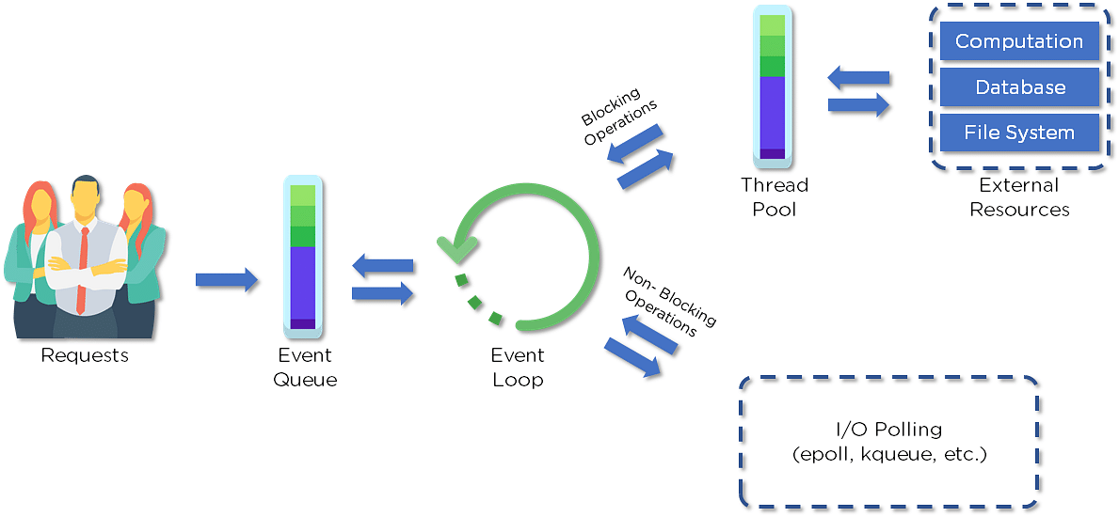

* Clients send requests to the webserver to interact with the web application. Requests can be non-blocking or blocking:
* Querying for data
* Deleting data
* Updating the data
* Node.js retrieves the incoming requests and adds those to the Event Queue
* The requests are then passed one-by-one through the Event Loop. It checks if the requests are simple enough not to require any external resources
* The Event Loop processes simple requests (non-blocking operations), such as I/O Polling, and returns the responses to the corresponding clients

A single thread from the Thread Pool is assigned to a single complex request. This thread is responsible for completing a particular blocking request by accessing external resources, such as computation, database, file system, etc.

Once the task is carried out completely, the response is sent to the Event Loop that sends that response back to the client.

**Q4. Is Node.js single-threaded? If yes then explain**

Yes,[Node.js is single-threaded](https://www.geeksforgeeks.org/why-node-js-is-a-single-threaded-language) by default.

**Q5. What is single-threaded in node js?**

Understanding Single-Threaded Architecture

In computing, a thread is the smallest unit of processing that can be scheduled by an operating system.

Traditional server-side applications often use a multi-threaded approach, where multiple threads handle multiple tasks concurrently. Each thread operates independently, allowing for parallel execution of code.

[Node.js](https://www.geeksforgeeks.org/nodejs/), on the other hand, employs a single-threaded model. This means it uses a single thread to handle multiple tasks. To achieve this, Node.js leverages an event-driven, non-blocking I/O model.

The Event Loop and Non-Blocking I/O

The core of Node.js’s single-threaded architecture is the event loop. The event loop continuously cycles through a series of phases, executing callbacks and handling events. Here’s a simplified breakdown of how it works:

**Event Queue**: Incoming requests are placed into an event queue.

**Event Loop:** The event loop picks up requests from the queue and processes them.

**Callbacks**: For each request, Node.js executes the associated callback function. If a callback involves a blocking operation (like file I/O or network requests), it delegates this to the thread pool.

**Thread Pool:** Node.js uses a thread pool (managed by the libuv library) to handle these blocking operations. Once completed, the results are placed back into the event queue for the event loop to process.

By default we have 4 threads at a time.

We can also Increase the Thread size but it’s depending upon our CPU.

Ex: If our CPU has 8 cores so the thread increases to 8.

This design allows Node.js to handle many connections simultaneously without creating a new thread for each connection. Instead, it efficiently manages I/O operations using non-blocking callbacks.

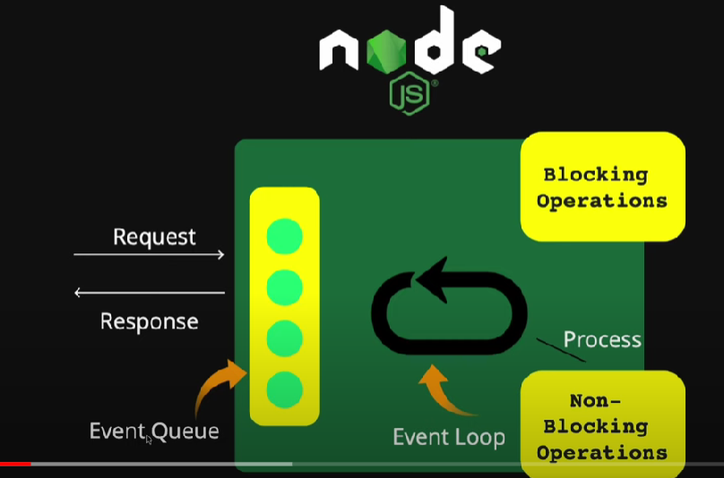

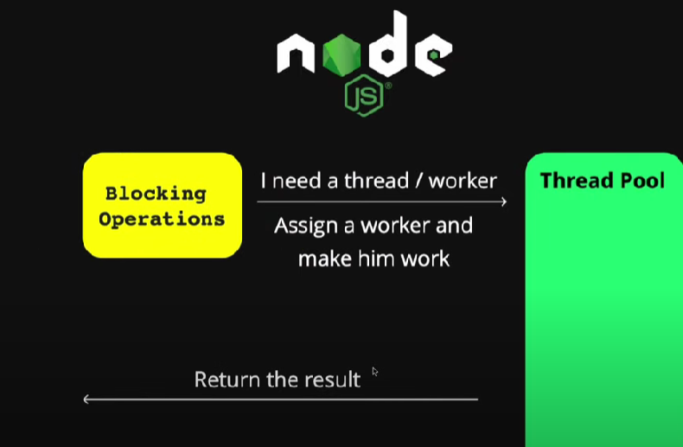

**Q6. What kind of API function is supported by Node.js?**

There are two types of [API functions](https://www.geeksforgeeks.org/types-of-api-functions-in-node-js) supported by Node.js:

Synchronous: These API functions are used for blocking code.

Asynchronous: These API functions are used for non-blocking code.

**Q7. What is the difference between Synchronous and Asynchronous functions?**

| **Feature** | **Synchronous Functions** | **Asynchronous Functions** |
| --- | --- | --- |
| Execution Blocking | Blocks the execution until the task completes. | Does not block the execution; allows other tasks to proceed concurrently. |
| Waiting for Completion | Executes tasks sequentially; each task must complete before the next one starts. | Initiates tasks and proceeds with other operations while waiting for completion. |
| Return Value | Returns the result immediately after completion. | Typically returns a promise, callback, or uses event handling to handle the result upon completion. |
| Error Handling | Errors can be easily caught with try-catch blocks. | Error handling is more complex and often involves callbacks, promises, or async/await syntax. |
| Usage Scenario | Suitable for simple, sequential tasks with predictable execution flow. | Ideal for I/O-bound operations, network requests, and tasks requiring parallel processing. |

**Q8. What are Modules in Node.js ?**

In Node.js Application, a Module can be considered as a block of code that provide a simple or complex functionality that can communicate with external application.

Modules can be organized in a single file or a collection of multiple files/folders.

Note: Nodejs uses the *CommonJS Module standard* implementation in its module ecosystem which allows you to create modular files and share functionality between them.

**Types of Modules:**In Nodejs, there is 3 type of modules namely

* Core Modules
* Local Modules
* Third-Party Modules

Core Modules

The built-in-module in the node.js is known as core module.

There are two types of core modules.

1. Global Module: The module which we can not require and use directly that module is known as global modules.

Ex: console.log

1. Non-Global Module : The modules which need to import using require method then use is known as non-global modules.

Ex: fs,HTTP,etx.

// Working code of fs module

const fs = require('fs'); // Import fs module

fs.writeFileSync('notes.txt', 'I love to code');

Here is the list of some Nodejs Core Modules:

|  |  |
| --- | --- |
| **Core Modules Name** | **Description** |
| fs | To handle the file system. |
| http | To make Node.js act as an HTTP server |
| https | To make Node.js act as an HTTPS server. |
| os | It provides information about the operation system. |
| path | To handle file paths. |
| cluster | To split a single Node process into multiple processes. |
| dns | To do DNS lookups and name resolution functions. |
| tls | To implement TLS and SSL protocols. |
| querystring | To handle URL query strings. |
| url | To parse URL strings. |
| events | To handle events |
| timers | To execute a function after a given number of milliseconds. |

**Local Module**

In Node.js, a local module refers to a module that is created and used within the scope of a specific project.

We don’t installed globally or shared across multiple projects.

Local modules are typically written by the developer and stored within the project's directory structure.

They are specific to the project and are not available outside of it unless explicitly shared.

**Key Characteristics of Local Modules:**

1. **Defined Within the Project**: Local modules are created as files or directories within the project. They are not installed from a central repository but are custom-defined by the developer.
2. **Scope**: They are only available to the project in which they are defined. This means they are included and used through relative paths or require statements specific to the project directory.
3. **No Global Impact**: Local modules do not affect or interact with other Node.js projects unless explicitly shared or included.
4. **Managed via module.exports and require**:
   * **Exporting**: In the module file, you use module.exports to specify what functionality (functions, objects, classes, etc.) should be made available to other files.
   * **Importing**: In other files within the same project, you use require with a relative path to include the local module and use its functionality.

**Example of a Local Module:**

1. **Creating the Module**:
   * Create a file named mathUtils.js in your project directory
2. // mathUtils.js
3. function add(a, b) {
4. return a + b;
5. }
6. function subtract(a, b) {
7. return a - b;
8. }
9. module.exports = { add, subtract };

**Using the Local Module**:

* Create another file, such as app.js, in the same project directory.
* // app.js
* const mathUtils = require('./mathUtils'); // Import the local module
* console.log(mathUtils.add(5, 3));       // Output: 8
* console.log(mathUtils.subtract(5, 3));  // Output: 2

**Third-party Modules:**

Third-party modules can be installed from the NPM (Node Package Manager) available online.

Firstly we need to initialize the npm using the *npm init*command before npm can be used. It creates a package.json file in the root directory and it stores all the information about the third-party module that we have installed as a dependency.

To install the third part module we write

npm install “module_name”

ex: npm install express, npm install bcrypt etc.

**Q9. What is npm?**

Npm stands for Node Package Manager.

It is a command-line tool and a package registry that allows developers to manage and share code packages or modules.

It makes it easy to add and use third-party libraries and tools created by other people in your Node.js applications.

Its advantages include dependency management, version control, centralized repository, and seamless integration with Node.js projects.

**Q10. What is middleware?**

[Middleware](https://www.geeksforgeeks.org/middleware-in-express-js) is the function that works between the request and the response cycle. Middleware gets executed after the server receives the request and before the controller sends the response.

**Types of Middleware**

Express JS offers different types of middleware and you should choose the middleware on the basis of functionality required.

* **Application-level middleware:**Bound to the entire application using **[app.use()](https://www.geeksforgeeks.org/express-js-app-use-function/)** or **[app.METHOD()](https://www.geeksforgeeks.org/express-js-app-method-function/)** and executes for all routes.
* **Router-level middleware**: Associated with specific routes using[**router.use()**](https://www.geeksforgeeks.org/express-js-router-use-function/) or **[router.METHOD()](https://www.geeksforgeeks.org/express-js-router-method-function/)** and executes for routes defined within that router.
* **Error-handling middleware:**Handles errors during the request-response cycle. Defined with four parameters (err, req, res, next).
* **Built-in middleware:**Provided by Express (e.g., express.static, express.json, etc.).
* **Third-party middleware**: Developed by external packages (e.g., body-parser, morgan, etc.).

**Q11. What is Control Flow?**

Control flow refers to the order in which individual statements, instructions, or function calls are executed or evaluated in a programming language.

Control flow mechanisms allow a program to make decisions, repeat operations, and jump to different sections of code based on certain conditions.

**Key Control Flow Mechanisms**

* **Sequential Execution:** Code is executed line by line, from top to bottom.
* **Conditional Statements:** if, else if, and else statements allow code to be executed based on specific conditions.
* **Loops:** for, while, and do...while loops enable repetitive execution of code blocks.
* **Function Calls:** Functions are invoked based on the program’s flow and the logic defined.
* **Exception Handling:** try, catch, and finally blocks manage errors and exceptions in the program.

**Q12. What is the Event Loop?**

The **event loop** in Node.js is a fundamental concept that enables **non-blocking, asynchronous programming**. It allows Node.js to perform **I/O operations** (like reading files, querying databases, or handling HTTP requests) without blocking the main thread.

It is done by assigning operations to the operating system whenever and wherever possible.

**Why Event Loop is important?**

Most operating systems are multi-threaded and hence can handle multiple operations executing in the background. When one of these operations is completed, the kernel tells Node.js, and the respective callback assigned to that operation is added to the event queue which will eventually be executed. This will be explained further in detail later in this topic.

Features of Event Loop:

* An event loop is an endless loop, which waits for tasks, executes them, and then sleeps until it receives more tasks.
* The event loop executes tasks from the event queue only when the call stack is empty i.e. there is no ongoing task.
* The event loop allows us to use callbacks and promises.
* The event loop executes the tasks starting from the oldest first.(FIFO)

**13. What are the main disadvantages of Node.js?**

Here are some main [disadvantages of Node.js](https://www.geeksforgeeks.org/the-pros-and-cons-of-node-js-in-web-development) listed below:

* **Single-threaded nature:** May not fully utilize multi-core CPUs, limiting performance.
* **NoSQL preference:** Relational databases like MySQL aren’t commonly used.
* **Rapid API changes:**Frequent updates can introduce instability and compatibility issues.

**Q14. What is REPL?**

Full form is **(READ, EVAL, PRINT, LOOP).**

It is Similar to the Shell (Unix/Linux) and command prompt, REPL is command prompt for node.js.

We can run our node.js code in REPL.

The work of REPL can be understood from its full form:

* **Read**: It reads the inputs from users and parses it into JavaScript data structure. It is then stored to memory.
* **Eval**: The parsed JavaScript data structure is evaluated for the results.
* **Print**: The result is printed after the evaluation.
* **Loop**: Loops the input command. To come out of NODE REPL, press **ctrl+c** twice

**15. What is the difference between Node.js and AJAX?**

Node.js is a JavaScript runtime environment that runs on the server side whereas AJAX is a client-side programming language that runs on the browser.

**Q16. What is package.json in Node.js?**

The **package.json** file is the heart of Node.js system.

It is a metadata file that contains project-specific information such as dependencies, scripts, version, author details, and other configuration settings required for managing and building the project.

**Q17. What is Event-Driven in Node.js**

Event-driven programming is a programming pattern that focuses on the flow of events or actions that occur within a program. In this pattern, the program responds to events as they occur, rather than executing code in a linear manner.

This approach is particularly useful for building interactive applications, such as web applications.

In Node.js, the event-driven model allows developers to write non-blocking, asynchronous code that responds to events as they occur, without waiting for blocking operations to complete.

In Node.js, events are handled using the EventEmitter class.

This class provides a way to raise and handle events within a program.

To use the EventEmitter class, you need to create an instance of it, and then use the on() method to attach event listeners to the instance. When an event occurs, the EventEmitter instance will call all registered listeners in order.

Here is an example code that demonstrates the use of EventEmitter in Node.js:

const EventEmitter = require('events');  
  
// create a new instance of EventEmitter

const myEmitter = new EventEmitter();

// attach a listener for the 'greet' event

myEmitter.on('greet', () => {

  console.log('Hello, world!');

});

// emit the 'greet' event

myEmitter.emit('greet');

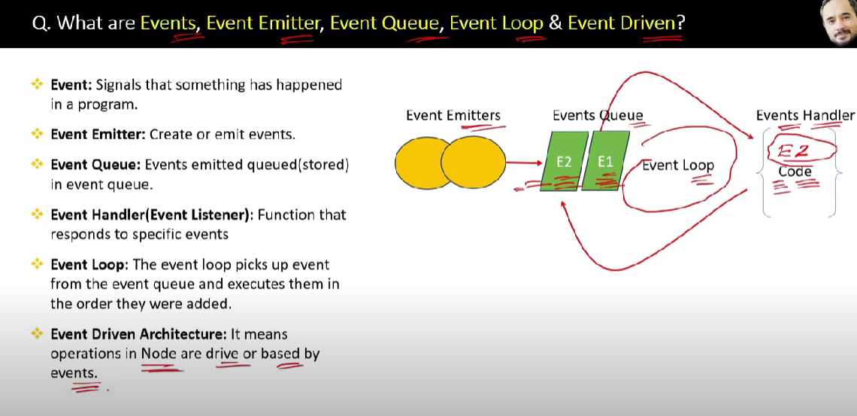

**Q18. What is Stream In Node.js?**

Streams are collections of data — just like arrays or strings.

Streams in NodeJS are a way to move data from a source to a destination in a bit-by-bit (or let’s say, in chunks), to avoid any Out-of-Memory Errors.

The difference is that streams might not be available all at once, and they don’t have to fit in memory.

This makes streams really powerful when working with large amounts of data, or data that’s coming from an external source one *chunk* at a time.

**Example 1**

To understand what exactly a stream does, let us consider a scenario.  
We have two buckets named source and destination. The source bucket is full of water, while the destination bucket is empty. We cannot move these two buckets from their spots, however, we have a third movable bucket called buffer. We can use this buffer to transfer water from source to destination.

Now, in the simplest of approach, let’s say, we transfer all the water from source to the buffer bucket. We carry this buffer to the destination, and then transfer everything from buffer to destination. However, there is an alternate approach as well, if we have a hose pipe called stream. We can connect source and destination with this stream, and then transfer water from source to destination in small amounts. This is what streams enable us with in NodeJS.

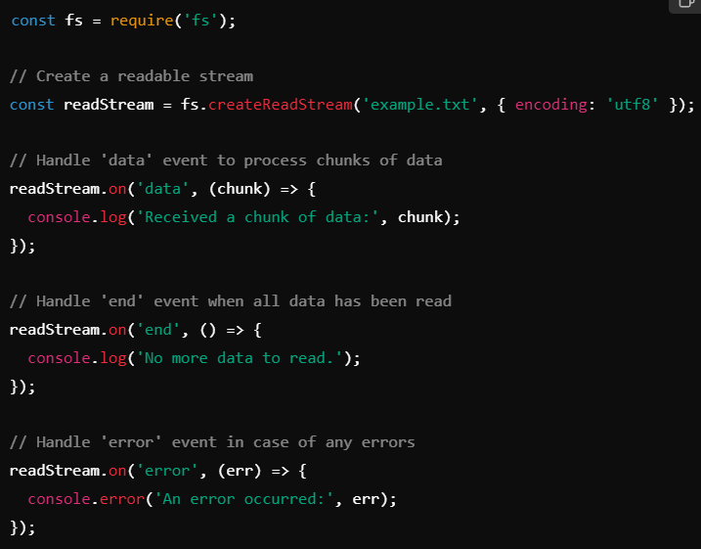

Explanation:

* fs.createReadStream('example.txt', { encoding: 'utf8' }): This creates a readable stream for the file example.txt. The encoding option is set to 'utf8' to read the file as a string.
* readStream.on('data', callback): This event is emitted whenever a chunk of data is available to read. The callback function processes each chunk.
* readStream.on('end', callback): This event is emitted when the stream has been fully read, indicating that there is no more data.
* readStream.on('error', callback): This event is emitted if an error occurs while reading the stream.

**Q19. What is Buffer in Node.js?**

The**Buffer class in Node.js** is used to **perform operations on raw binary data**. Generally, **Buffer refers to the particular memory location in memory**.

Buffer and array have some similarities, but the difference is array can be any type, and it can be resizable.

Buffers only deal with binary data, and it can not be resizable

Buffer is 8-bit unsigned array.

Binary data refers to data that consists of binary values, as opposed to text data, which consists of characters and symbols.

Examples of binary data include images, audio and video files, and raw data from a network.

**Why buffers are needed:**

* JavaScript strings are UTF-16 encoded, so they are not suitable for representing arbitrary binary data.
* Buffers allow Node.js to handle raw data more efficiently and safely.
* When reading data from a file or network socket, the data often arrives as binary, and buffers provide a structured way to manipulate it.

**Buffer Methods:**

| **No** | **Method** | **Description** |
| --- | --- | --- |
| **1** | Buffer.alloc(size) | It creates a buffer and allocates size to it. |
| **2** | Buffer.from(initialization) | It initializes the buffer with given data. |
| **3** | Buffer.write(data) | It writes the data on the buffer. |
| **4** | toString() | It read data from the buffer and returned it. |
| **5** | Buffer.isBuffer(object) | It checks whether the object is a buffer or not. |
| **6** | Buffer.length | It returns the length of the buffer. |
| **7** | Buffer.copy(buffer,subsection size) | It copies data from one buffer to another. |
| **8** | Buffer.slice(start, end=buffer.length) | It returns the subsection of data stored in a buffer. |
| **9** | Buffer.concat([buffer,buffer]) | It concatenates two buffers. |

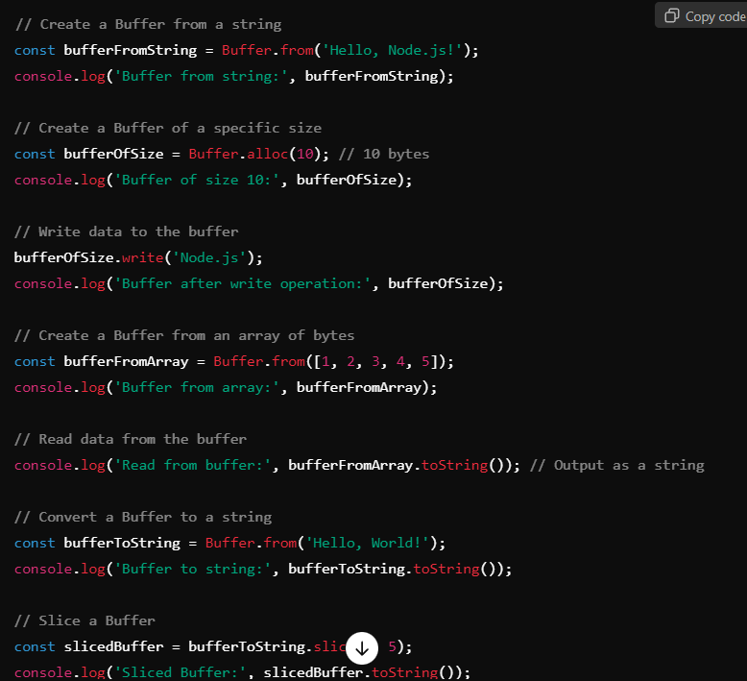

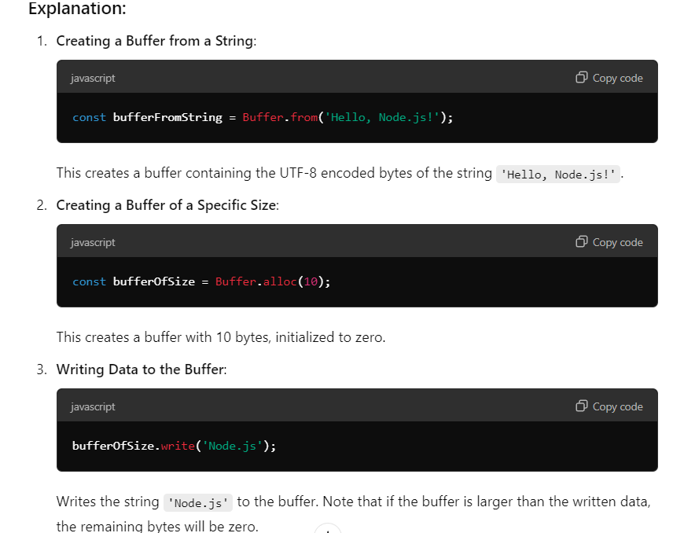

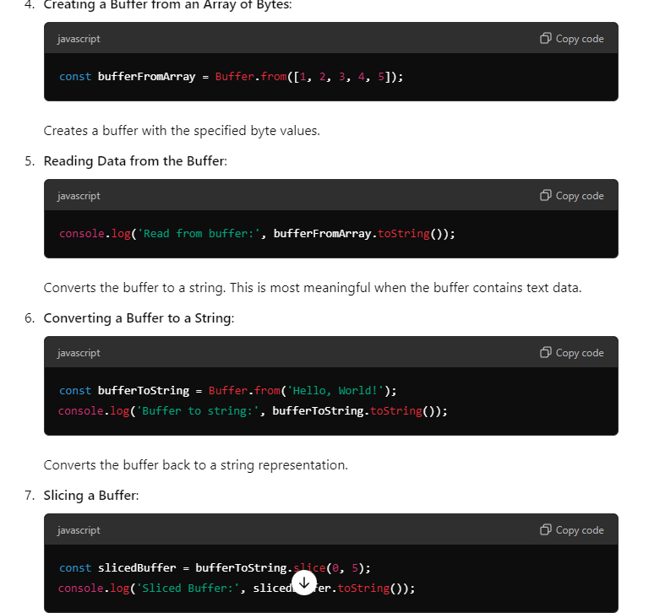

**Q20. What is the Crypto Module?**

The crypto module in Node.js is part of the core libraries, meaning it is built into Node.js and does not require any external dependencies. It provides a way to perform cryptographic operations such as:

* Hashing data to produce fixed-size digests.
* Encrypting and decrypting data using symmetric and asymmetric algorithms.
* Generating cryptographic signatures and verifying them.
* Creating secure random numbers and keys.

These capabilities make the crypto module an essential tool for developing secure applications that require data integrity, confidentiality, and authentication.

**Q21 . Explain Some important modules of Node.js?**

There are many modules in which some are very important

1. Fs module
2. Path module
3. Os module
4. Http Module

**File System Module**

The Node.js file system module allows developers to work with the file system on your computer.

To include the File System module, use the require() method:

const fs = require('fs');

**Uses:**

* Read Files
* Write Files
* Append Files
* Close Files
* Delete Files

**Key Features**

* **Asynchronous and Synchronous Methods:**Provides both non-blocking and blocking methods for various file operations.
* **Error Handling:**Includes robust error handling to manage issues such as file not found or permission errors.
* **Directory Management:**Allows creation, deletion, and listing of directories.

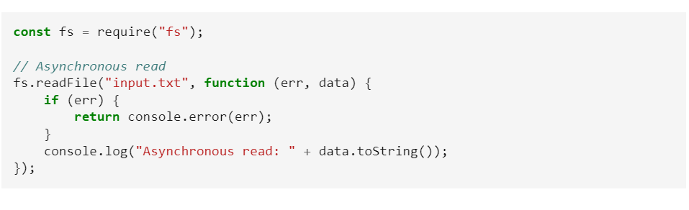

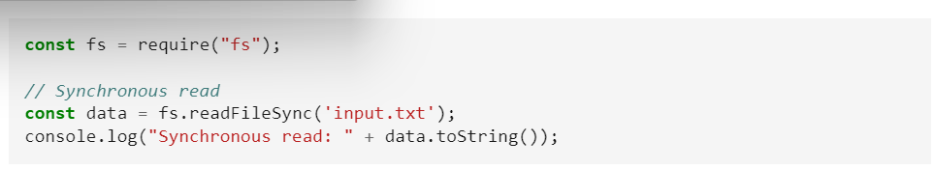

**Open a File**

The fs.open() method is used to create, read, or write a file.

The fs.readFile() method is only for reading the file and

fs.writeFile() method is only for writing to the file,

whereas fs.open() method does several operations on a file. First, we need to load the fs class which is a module to access the physical file system.

Syntax:

fs.open(path, flags, mode, callback)

Parameters:

* path: It holds the name of the file to read or the entire path if stored at other locations.
* flags: Flags indicate the behavior of the file to be opened. All possible values are ( r, r+, rs, rs+, w, wx, w+, wx+, a, ax, a+, ax+).
* mode: Sets the mode of file i.e. r-read, w-write, r+ -readwrite. It sets to default as readwrite.
* err: If any error occurs.
* data: Contents of the file. It is called after the open operation is executed.

Example: Let us create a js file named main.js having the following code to open a file input.txt for reading and writing.

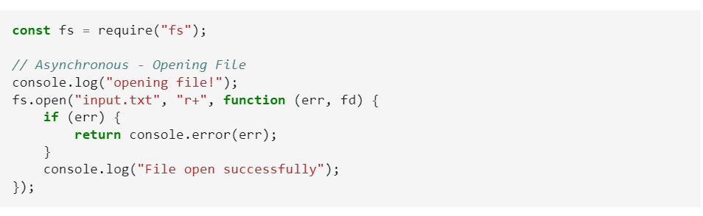

**HTTP Module**

The HTTP module in Node.js provides utilities for creating HTTP servers and clients.

It’s a fundamental part of Node.js, enabling the handling of HTTP requests and responses.

The HTTP module creates an HTTP server that listens to server ports and gives a response back to the client.

**Syntax:**

const http = require('http');

**Creating Servers:**

The HTTP module allows you to create a server using the http.createServer() method, which listens for incoming requests and handles them using a callback function.

**Handling Requests:**

You can handle HTTP requests and responses by accessing the request and response objects within the callback function of createServer(). The request object contains data from the client, while the response object is used to send data back.

**Making Requests:**

The HTTP module also provides methods for making HTTP requests from a Node.js application. You can use http.request() or http.get() to send requests to other servers and handle their responses.

**Features**

* Easily create and configure HTTP servers with custom logic.
* Handle HTTP methods, headers, and data streams.
* No need for external libraries to handle HTTP in Node.js.

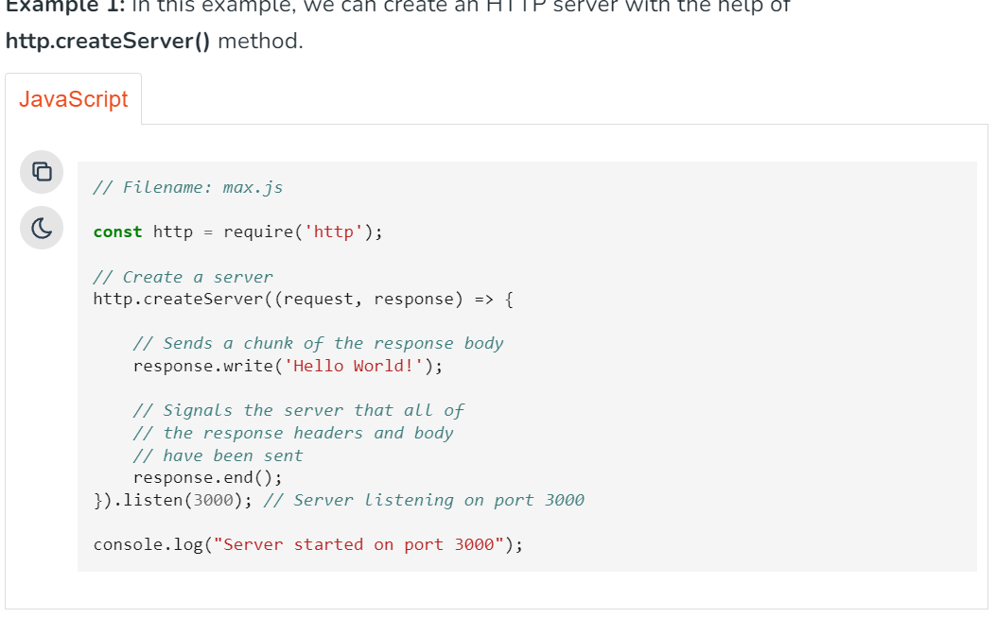

To make requests via the HTTP module **http.request()** method is used.

**Syntax:**

http.request(options[, callback])

**Example 2:** In this example, we will see to make requests via the HTTP module **http.request()** method.

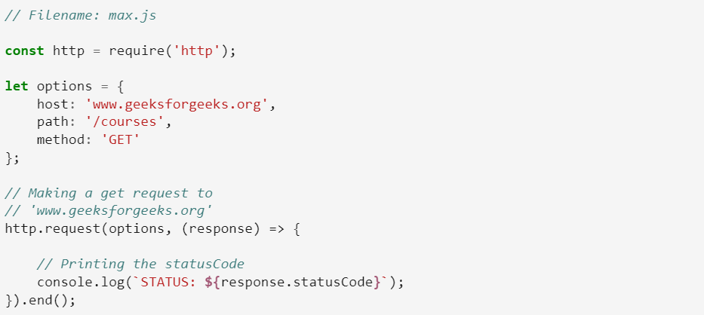



**Path Module**

The Path Module in Node.js provides the utilities for working with file and directory paths

**Q22. What is Express.js ?**

**Express.js** is a fast, flexible and minimalist web framework for Node.js.

Express is a user-friendly framework that simplifies the development process of Node applications.

It uses JavaScript as a programming language and provides an efficient way to build web applications and APIs.

**There are some advantages of Express.js**

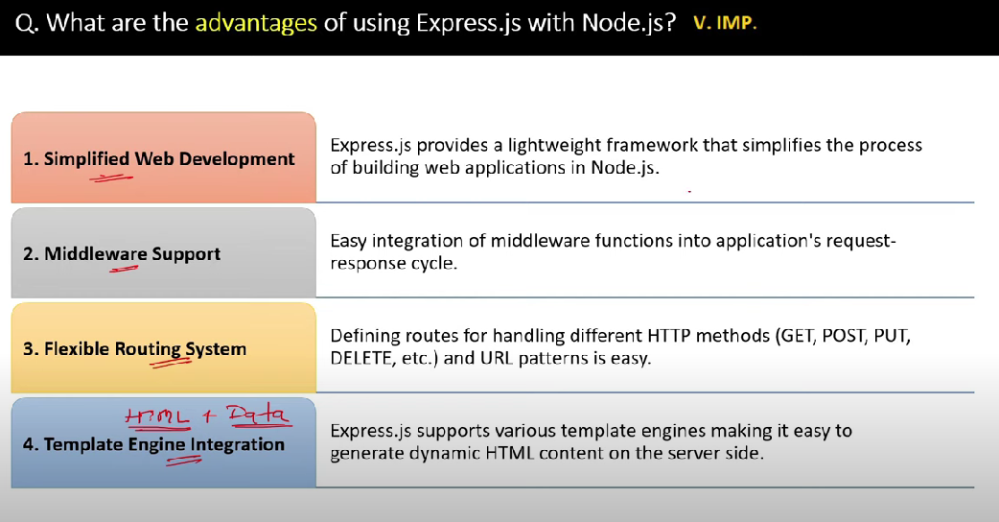

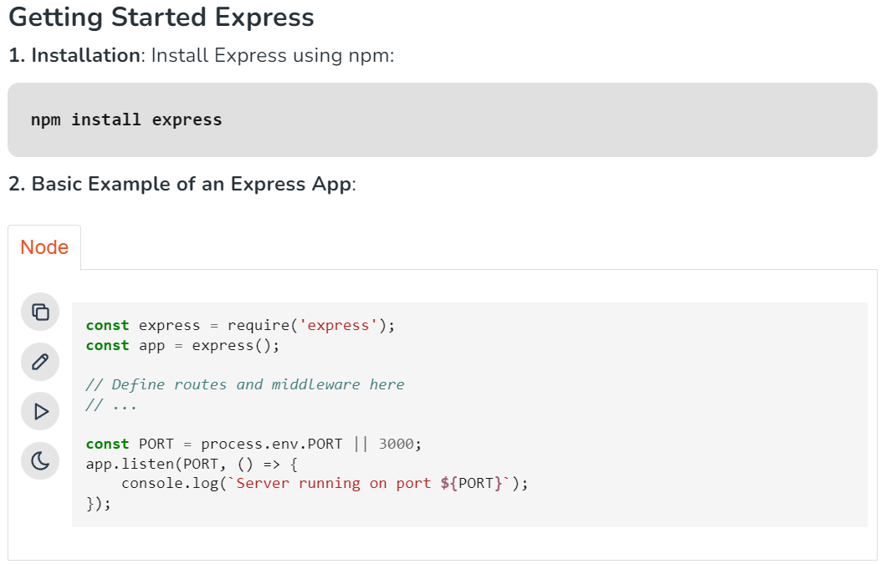

**Q23.** **What is a Middleware**

Middleware in Express.js refers to functions that execute during the request-response cycle. They have access to the request object (req), the response object (res), and the next middleware function in the stack (next).

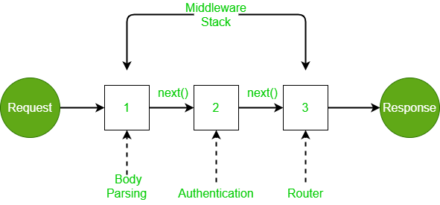

A middleware function can perform the following tasks:

* It can execute any code.
* It can make changes to the request and the response objects.
* It can end the request-response cycle.
* It can call the next middleware function in the stack.
* Middleware can be used to add logging and authentication functionality.
* Middleware improves client-side rendering performance.
* Middleware is used for setting some specific HTTP headers.
* Middleware helps with Optimization and better performance.

**Following is a list of possibly used middleware in Express.js app:**

* Application-level middleware
* Router-level middleware
* Error-handling middleware
* Built-in middleware
* Third-party middleware

**Example**

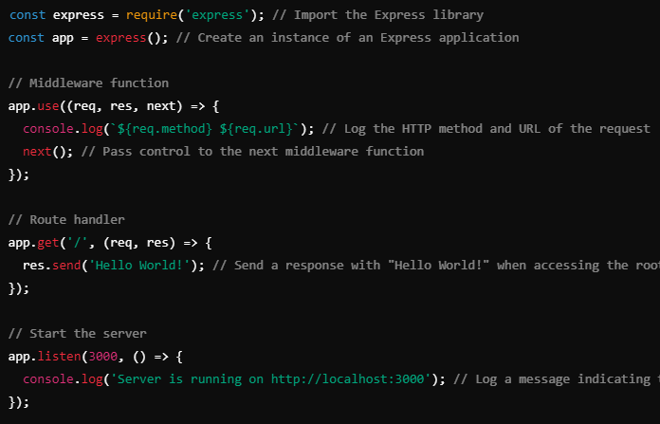

**Explanation**

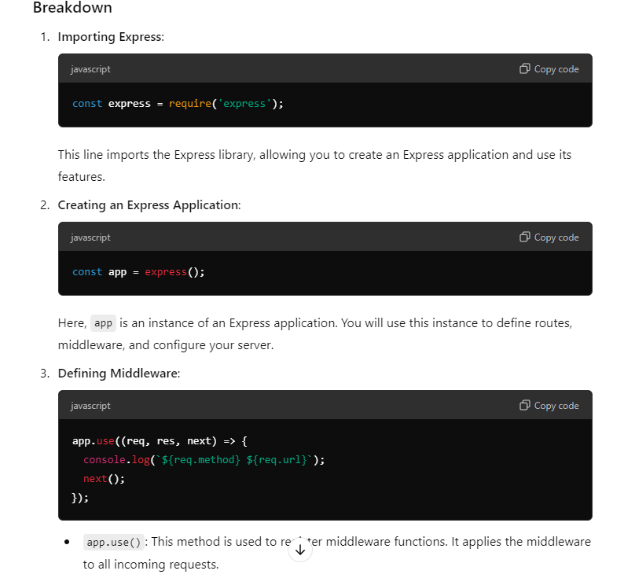

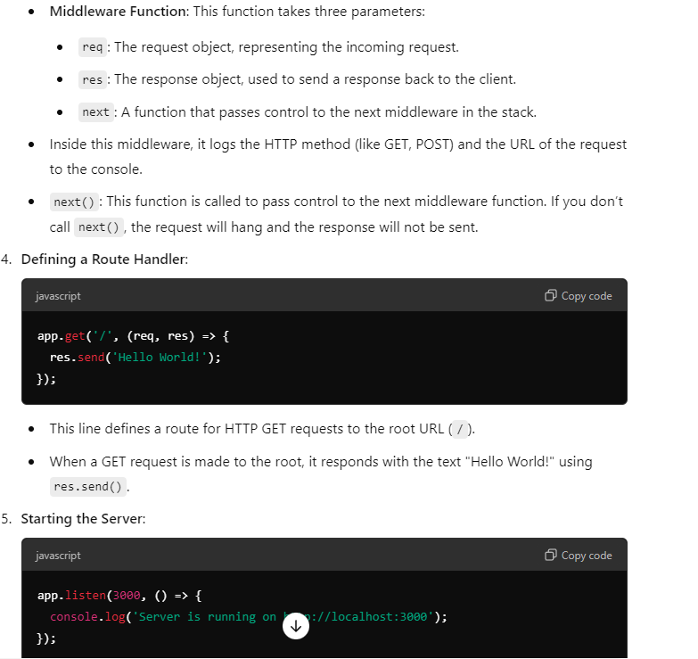

**Q24 What is the use of app.use function in express.js?**

It is used to execute the middleware functions globally.

It means it run for all the request which come to server.

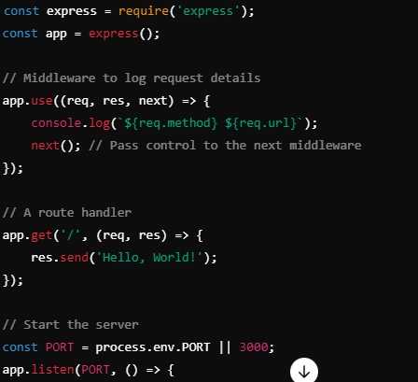

**Q25. What is the use of next() function in express.js?**

The next parameter is a callback function which is use to pass control to the next middleware function in the stack.

When you call next(), it tells Express to move on to the next middleware function.

If you don't call it, the request will hang and not move forward.



**Q26 What is Request Pipeline in express.js?**

In Express js It is a series of middleware that handles the HTTP request and pass controller to next function.

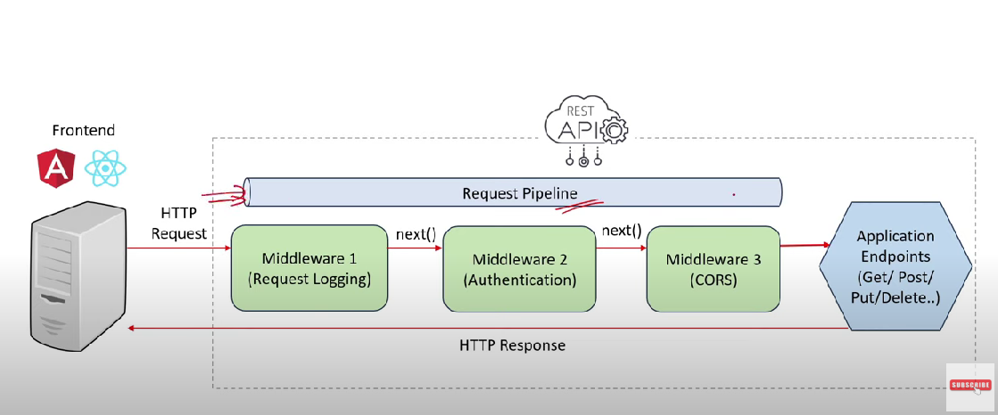

**Q27. What is Application and Router level middleware in express.js?**

**Application Level Middleware**

Application level middleware is applied to the entire Express.js application.

It means that every incoming request, regardless of the route, will pass through this middleware function.

Application level middleware is typically used for tasks that need to be performed for every request, such as:

Logging requests

Authentication and authorization

Compressing responses

Serving static files

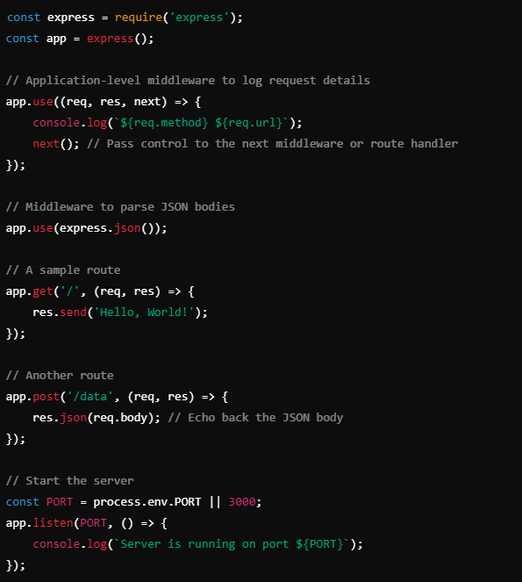

**Router Level Middleware**

Router level middleware, on the other hand, is applied to a specific router instance.

It means that only requests that are routed through that specific router will pass through this middleware function.

Router level middleware is typically used for tasks that are specific to a particular route or set of routes, such as:

* **Validating input data for a specific route**
* **Authenticating users for a specific route**
* **Caching responses for a specific route**

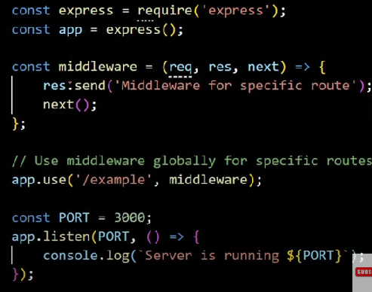

**Error Handling Middleware**

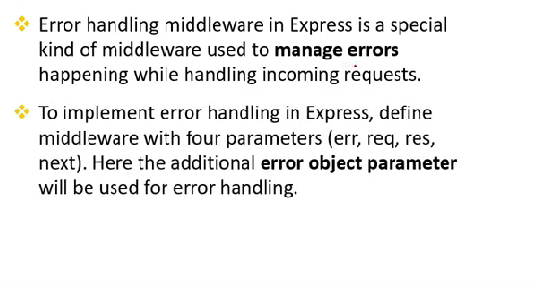

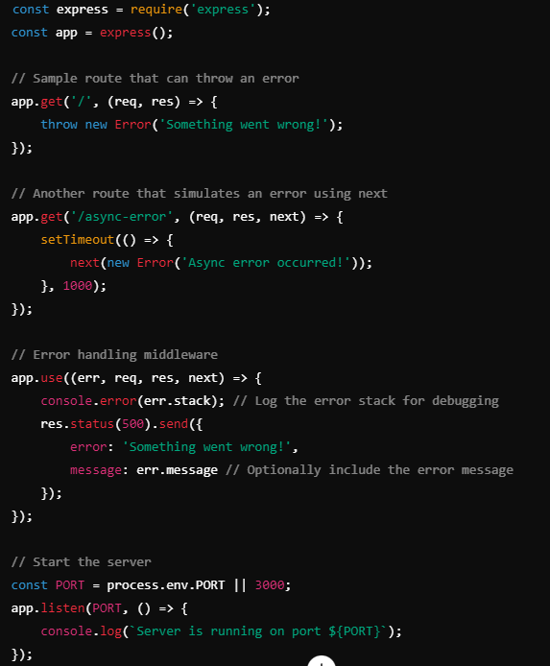

**Buitl In Middleware**

In Express.js, built-in middleware refers to functions that are provided by the Express framework to handle common tasks in the request-response cycle.

These middleware functions can be used to process incoming requests, add functionalities, and manipulate the response before it’s sent back to the client.

Here are some of the commonly used built-in middleware in Express.js:

1. **express.json()**: Parses incoming JSON requests and puts the parsed data in req.body.
2. **express.urlencoded()**: Parses incoming requests with URL-encoded payloads (typically form submissions) and populates req.body. It has an option to set the extended property to use the querystring library for parsing or to use the qs library for rich objects and arrays.
3. **express.static()**: Serves static files such as images, CSS, and JavaScript. You provide the directory path where the static assets are stored.
4. **express.Router()**: While not middleware in the strictest sense, it allows you to create modular route handlers, which can be treated as middleware to organize your routes better.

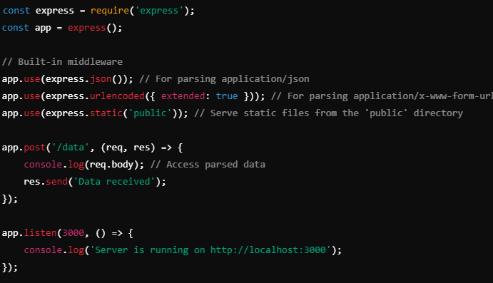

**Third Party Middleware**

Third-party middleware in Express.js refers to middleware functions that are not included with the Express framework itself but can be installed from npm (Node Package Manager) or other sources.

These middleware packages provide additional functionality that enhances the capabilities of an Express application.

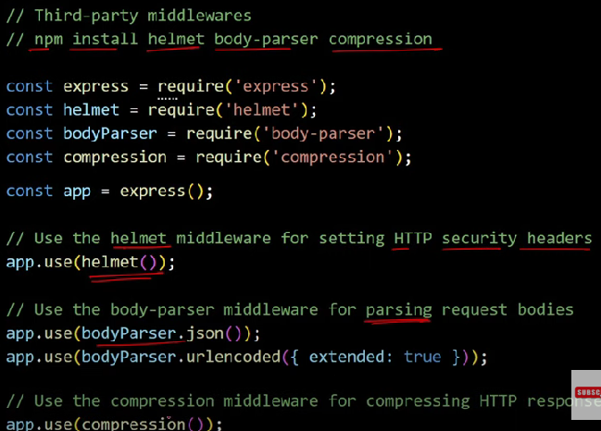

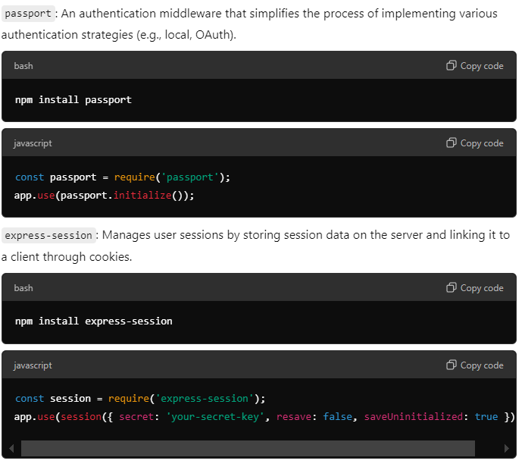

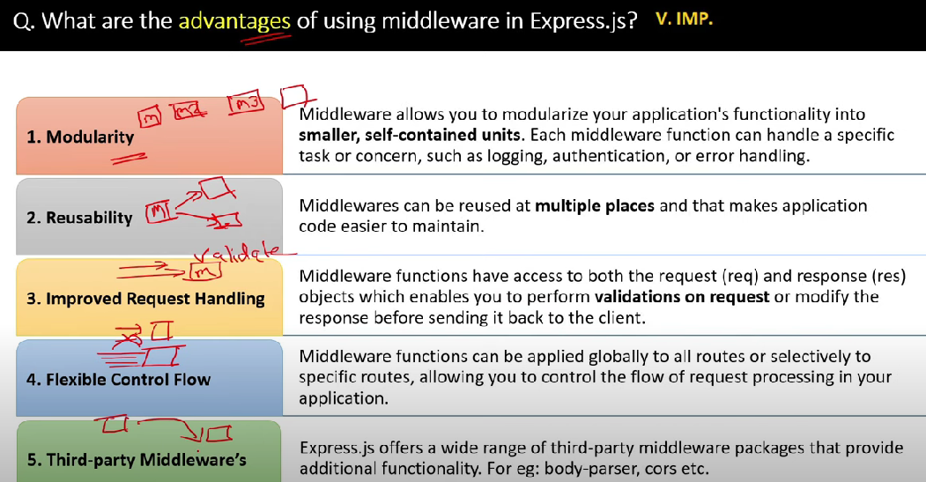

**Q27. What is Routing in Express.js?**

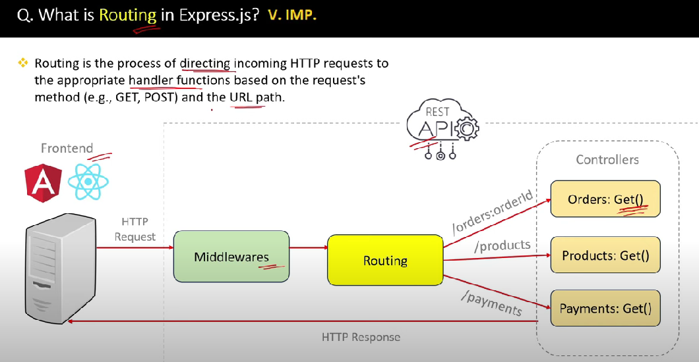

**Q28. What is difference between Routing and Middleware?**

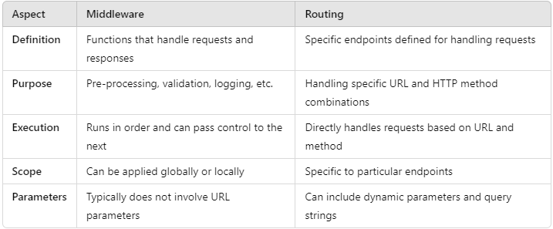

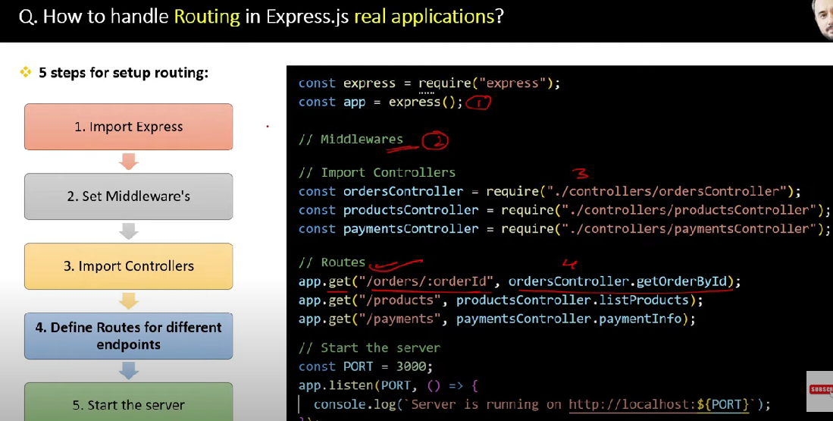

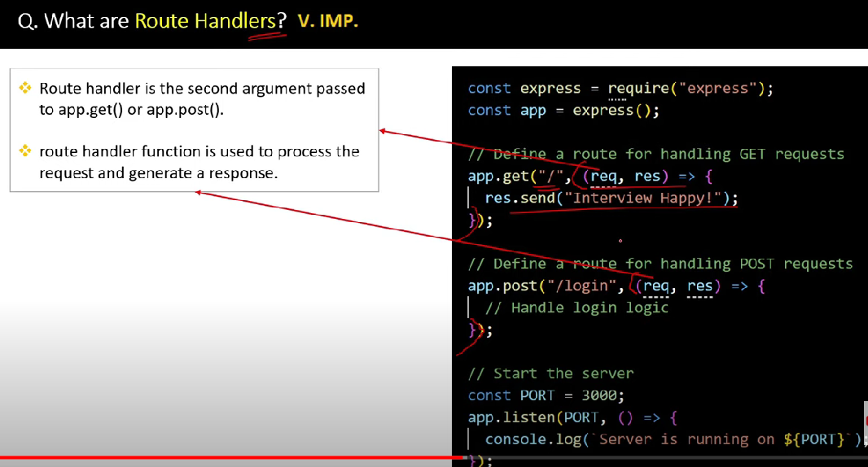

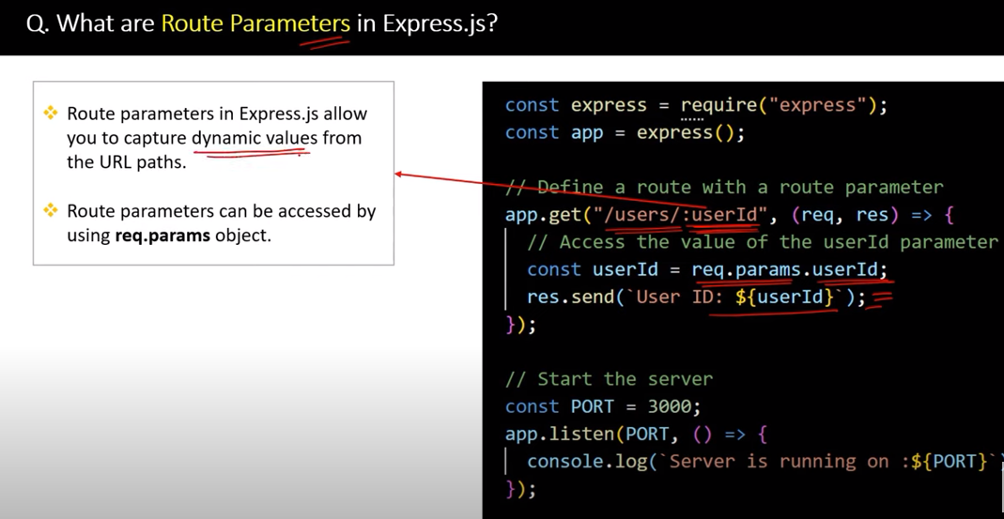

**Q28. What is route Parameter ?**

In Express.js, **route parameters** are placeholders in the route path that allow you to capture specific values from the URL.

They are useful for building dynamic routes where you need to access specific pieces of information from the URL, such as user IDs, product IDs, or other identifiers.

Route parameters are defined using a colon (:) followed by the parameter name in the route path.

You can access the route parameters through the req.params object.

Each parameter is stored as a key-value pair, where the key is the parameter name without the colon.

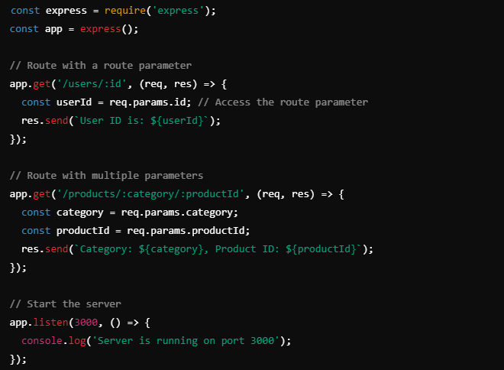

Q29. What is Router Object and Router Method?

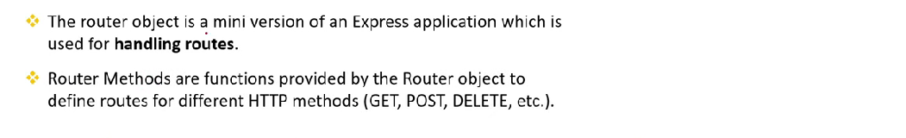

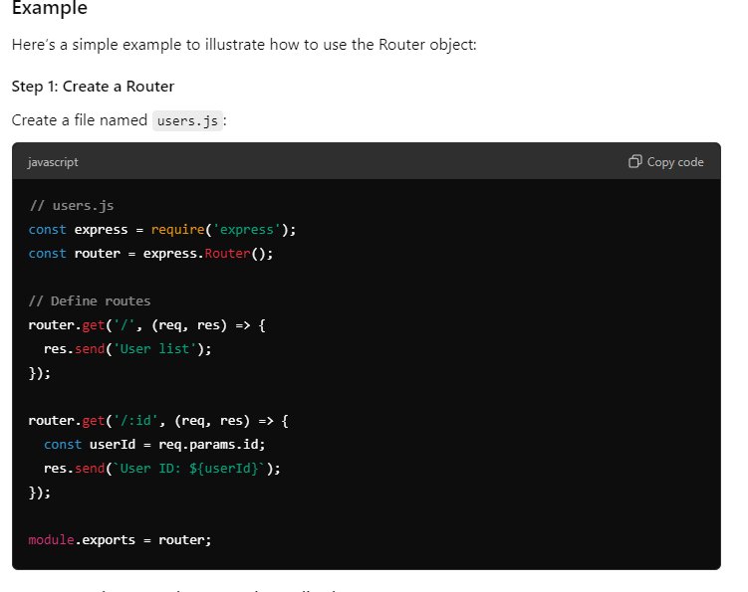

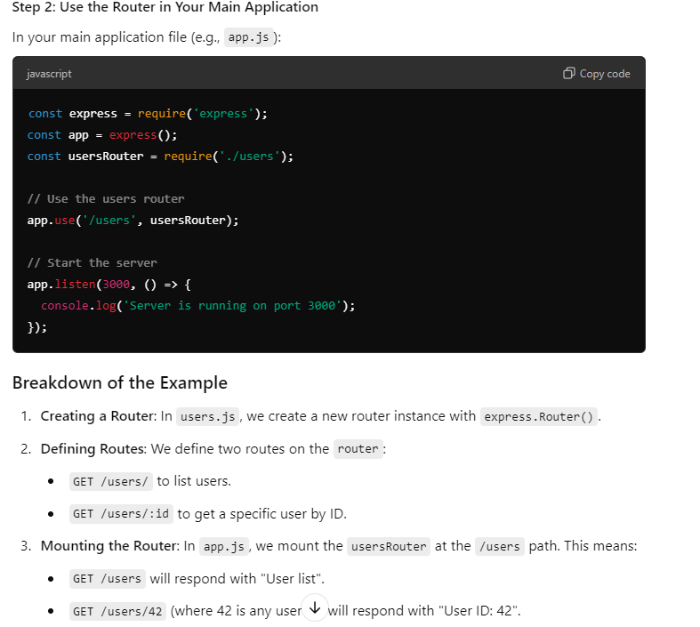

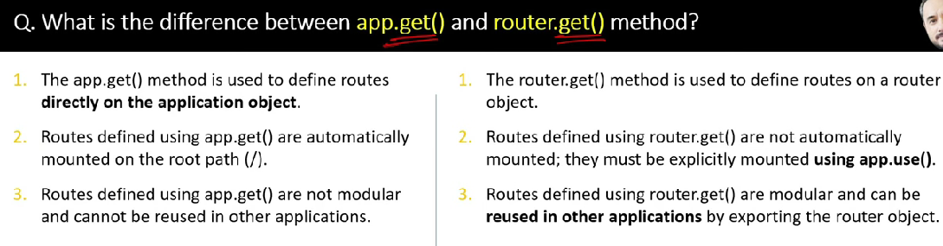

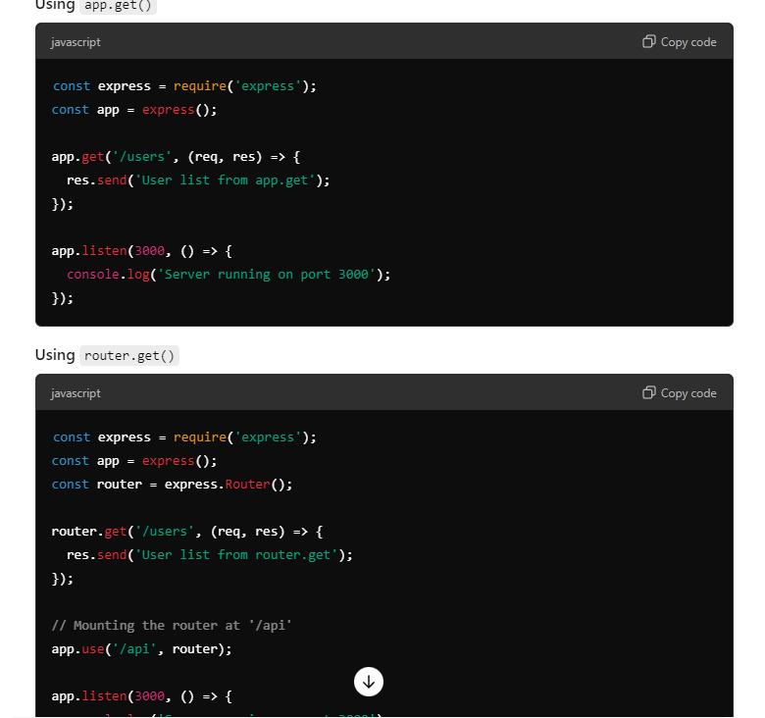

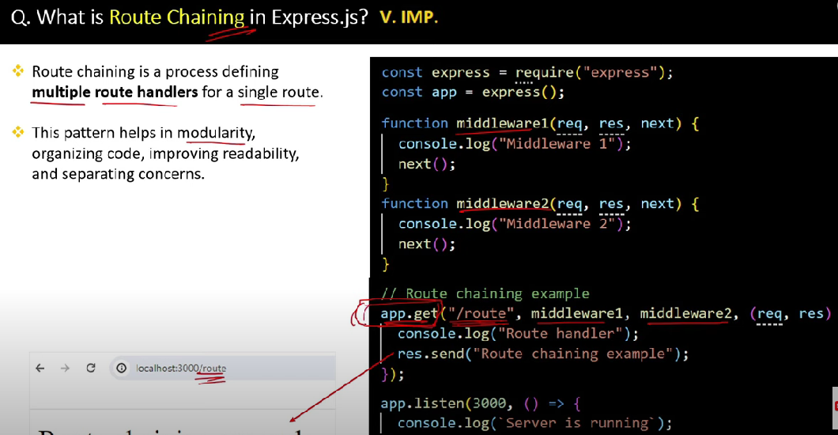

**Example**

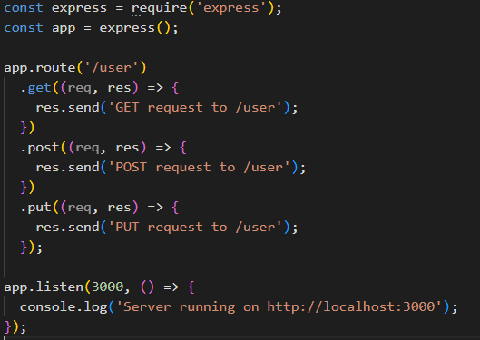

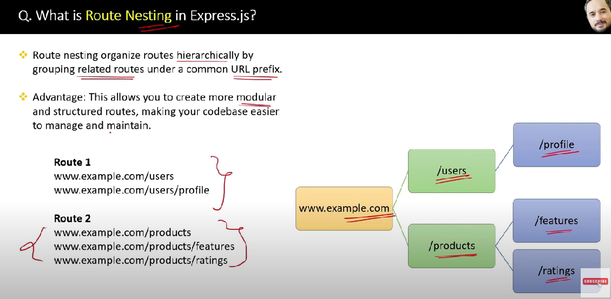

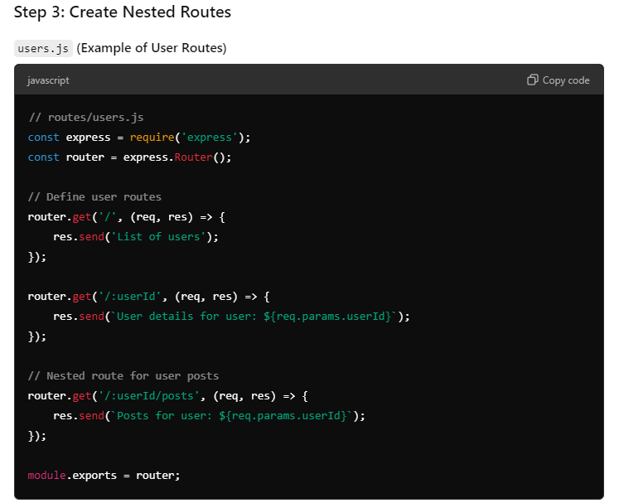

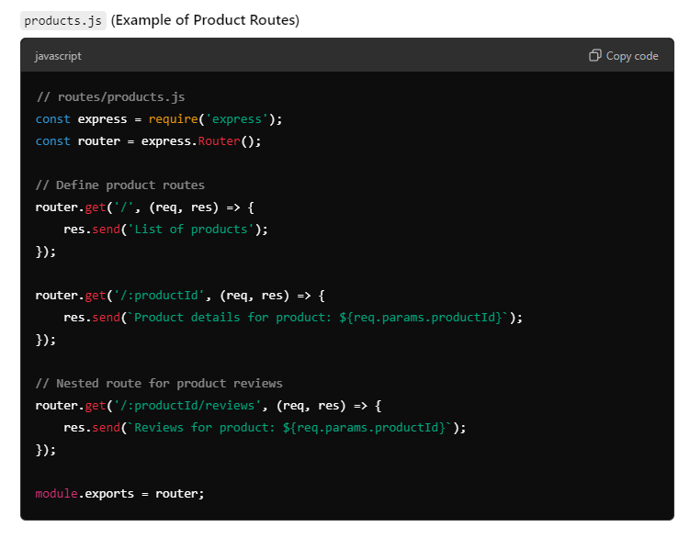

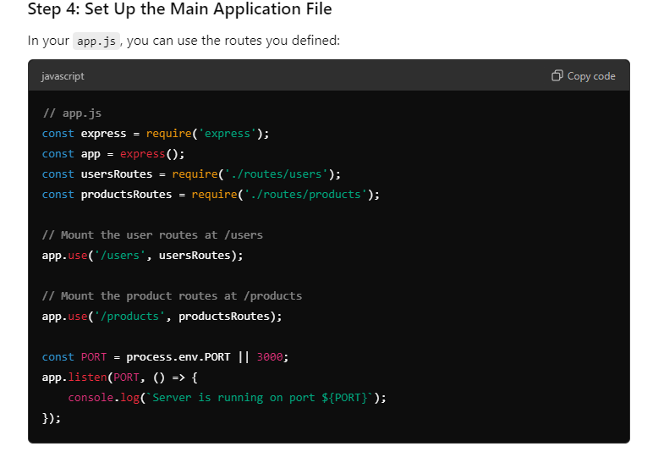

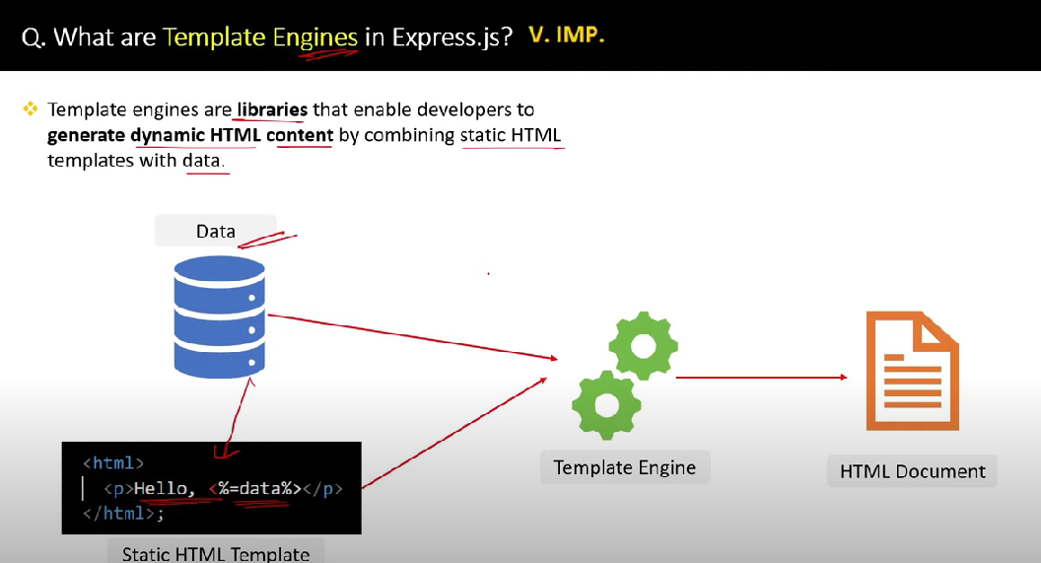

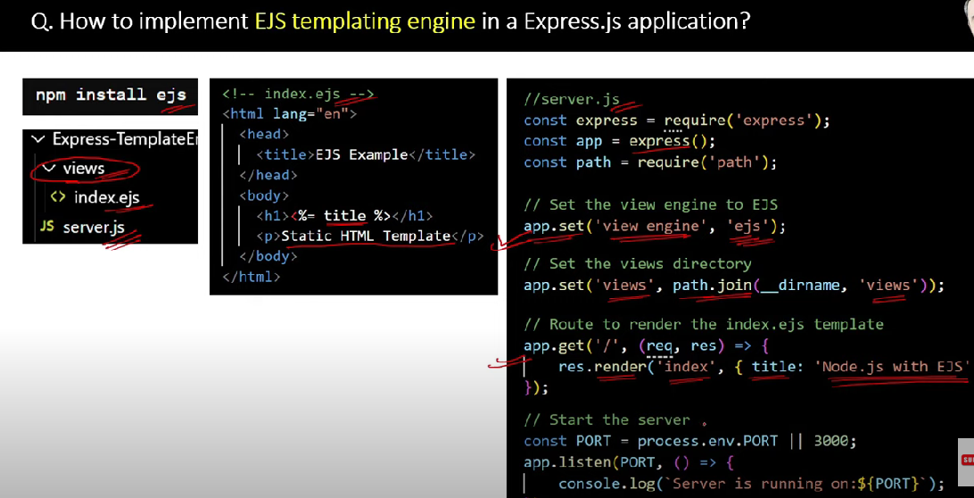

**REST and RESTFUL API**

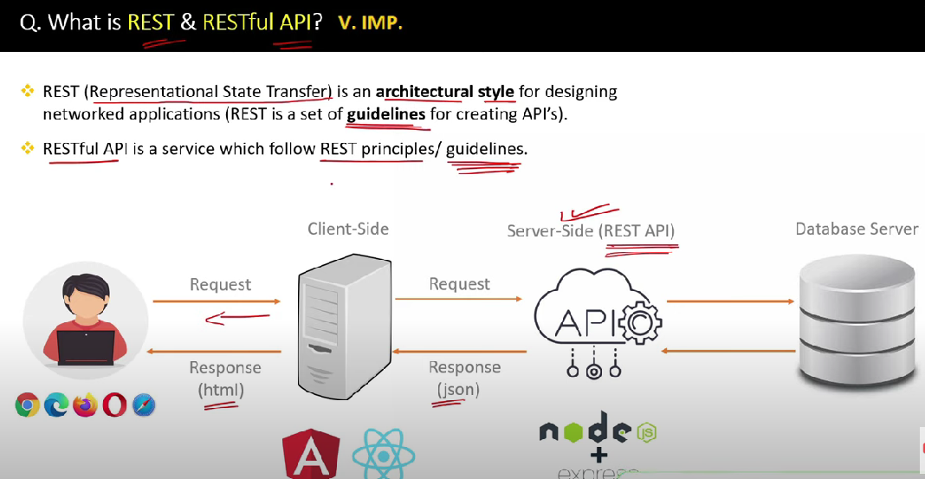

**HTTP Request and Response Overview**

HTTP (HyperText Transfer Protocol) is the foundation of data communication on the web. It defines how messages are formatted and transmitted between clients (usually browsers) and servers.

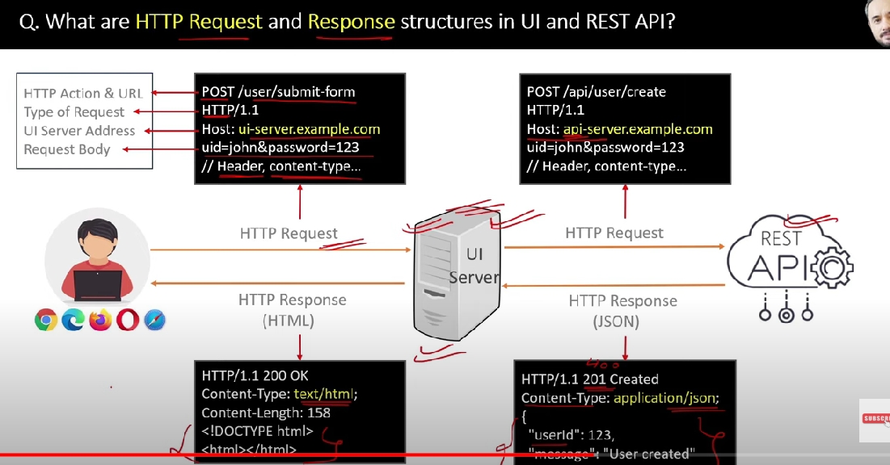

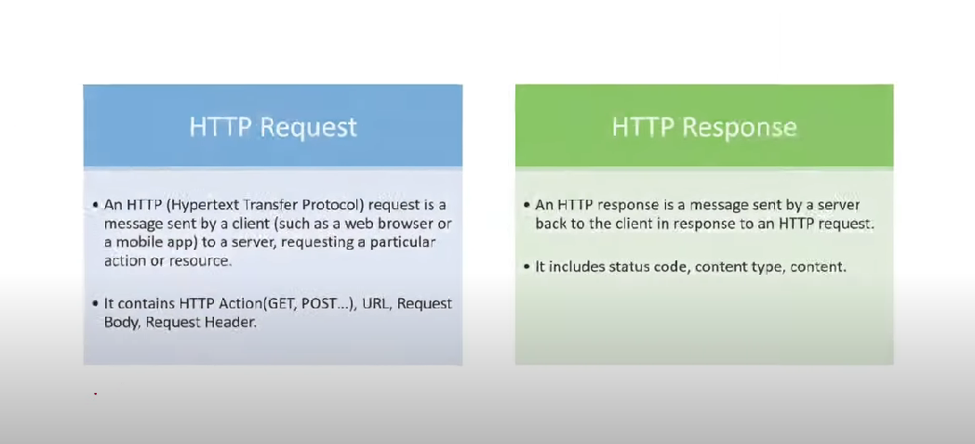

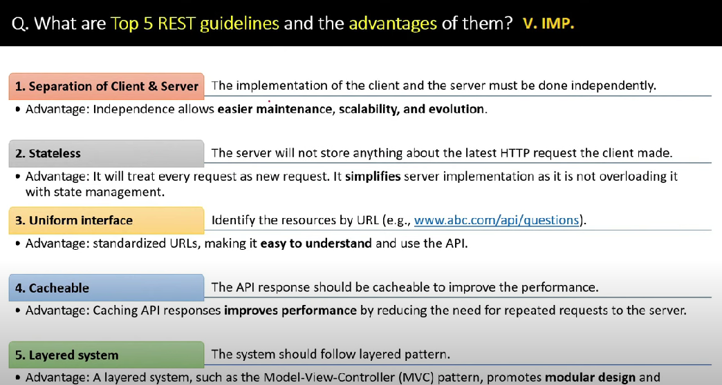

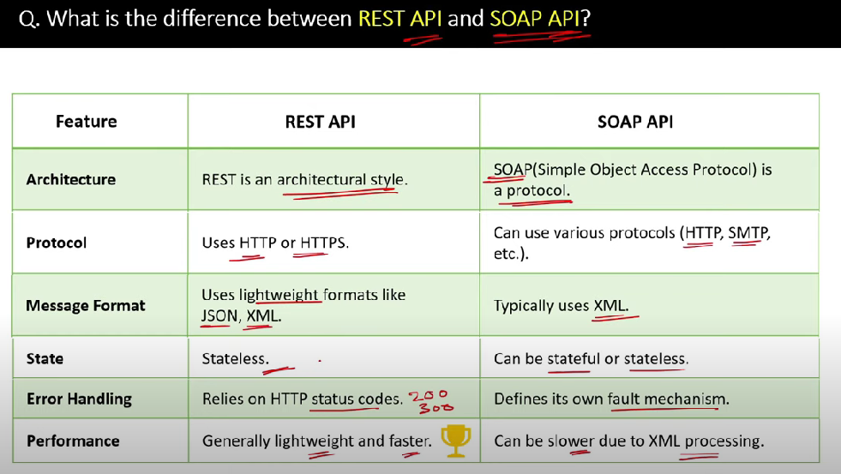

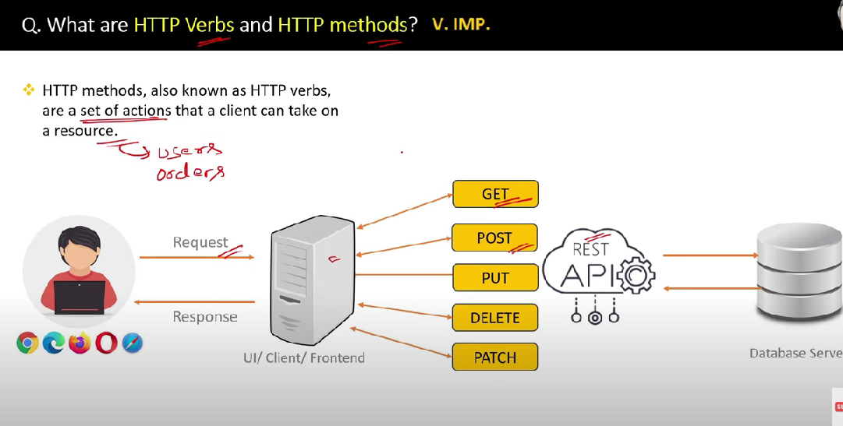

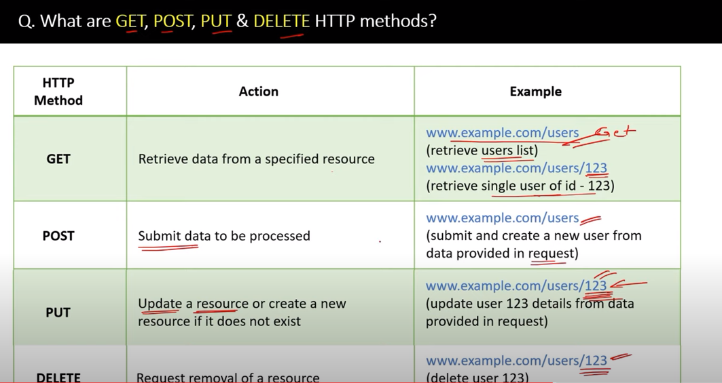

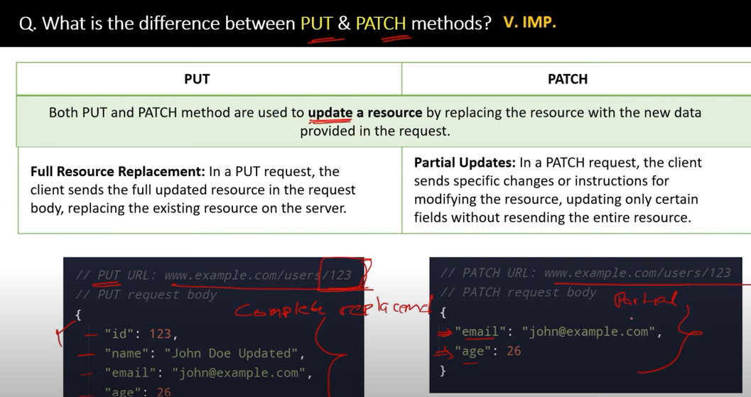

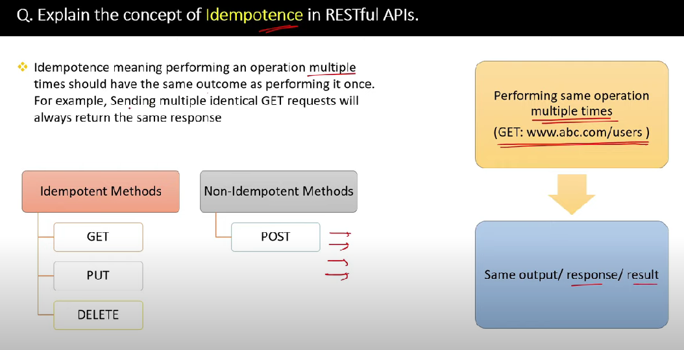

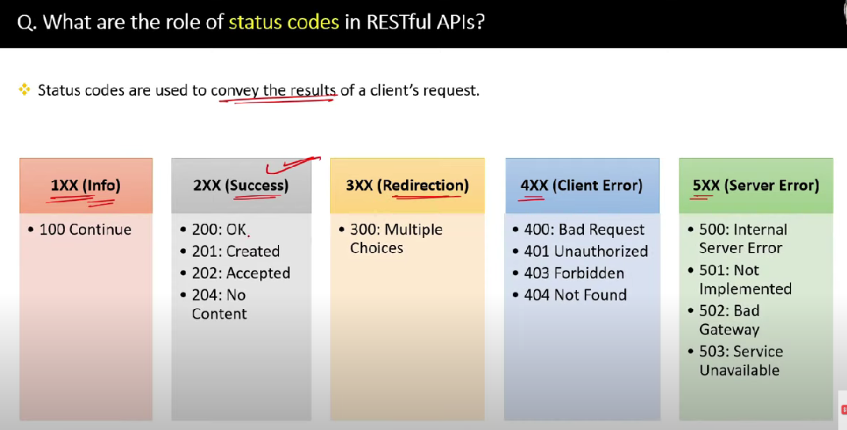

**✅ 200 OK**

* **Meaning: The request was successful.**
* **Use Case: Standard response for successful HTTP requests.**
* **Example: A GET request to fetch user data returns the data with a 200 status.**

**🆕 201 Created**

* **Meaning: The request was successful, and a new resource was created.**
* **Use Case: Typically used with POST requests when creating a new item.**
* **Example: Submitting a form to create a new user account returns 201 with the new user’s URL.**

**📬 202 Accepted**

* **Meaning: The request has been accepted for processing, but the processing is not complete.**
* **Use Case: Used when the server needs more time to process the request (e.g., background jobs).**
* **Example: Uploading a large file that will be processed later.**

**🚫 204 No Content**

* **Meaning: The request was successful, but there is no content to return.**
* **Use Case: Often used with DELETE or PUT requests.**
* **Example: Deleting a user returns 204 to indicate success, but no response body is needed.**

**400 Bad Request**

* **Meaning: The server cannot process the request due to a client error (e.g., malformed request syntax, invalid request message).**
* **Example: Sending a malformed JSON payload in a POST request.**
* **Use Case: Useful for validating input and returning a clear error when the request is incorrect.**

**🔐 401 Unauthorized**

* **Meaning: Authentication is required and has either not been provided or is invalid.**
* **Example: Accessing a protected API without a valid token.**
* **Use Case: Prompt the user to log in or provide valid credentials.**

**🔸 Note: Despite the name, it’s about authentication, not authorization.**

**🚫 403 Forbidden**

* **Meaning: The server understands the request but refuses to authorize it.**
* **Example: A logged-in user tries to access an admin-only page.**
* **Use Case: Used when the user is authenticated but not allowed to access the resource.**

**❓ 404 Not Found**

* **Meaning: The requested resource could not be found on the server.**
* **Example: Visiting a URL that doesn’t exist.**
* **Use Case: Commonly used for broken or incorrect links.**

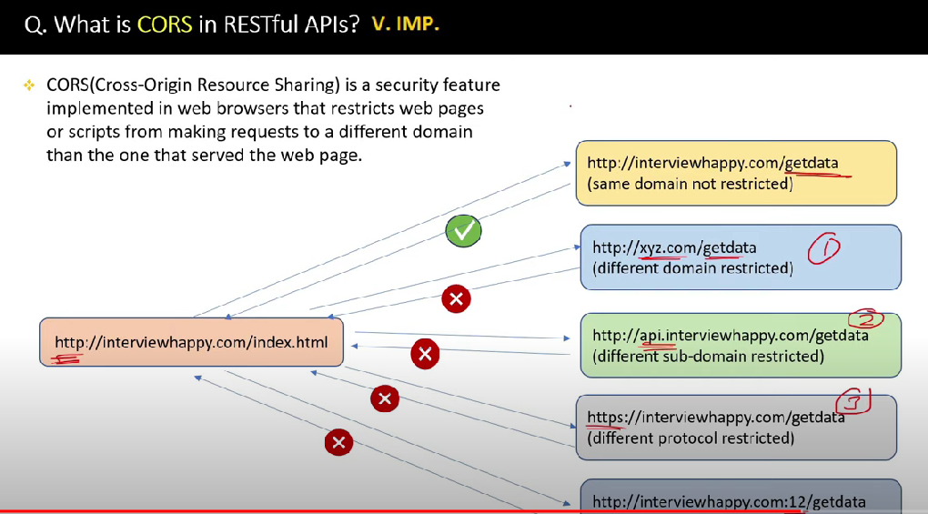

**Why CORS Matters**

When a web application makes a request to a different origin (domain, protocol, or port), the browser performs a CORS check. If the server does not explicitly allow requests from that origin, the browser will block the request, resulting in a CORS error.

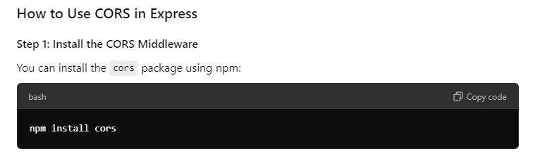

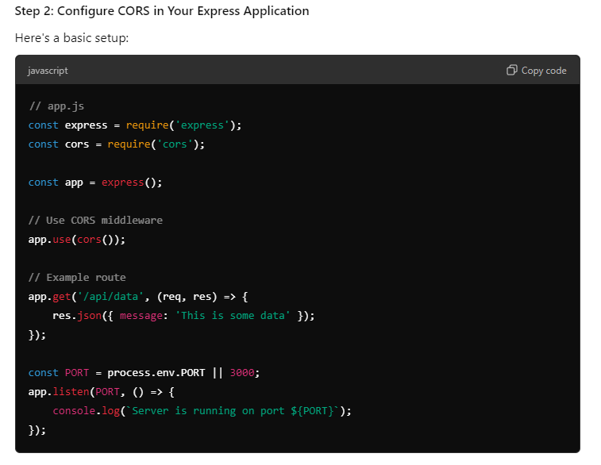

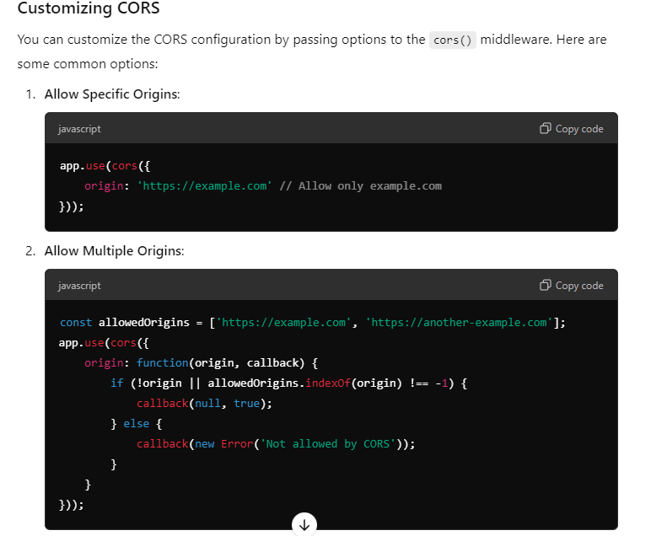

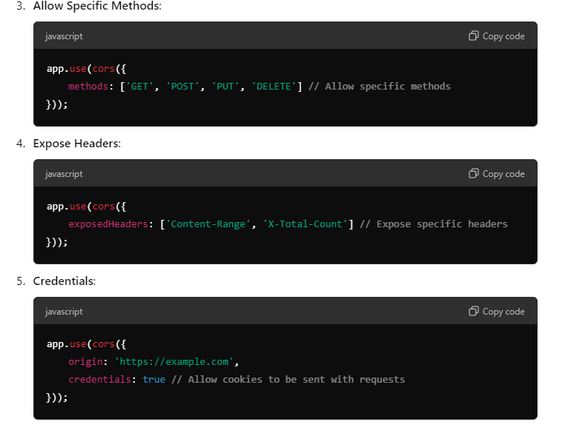

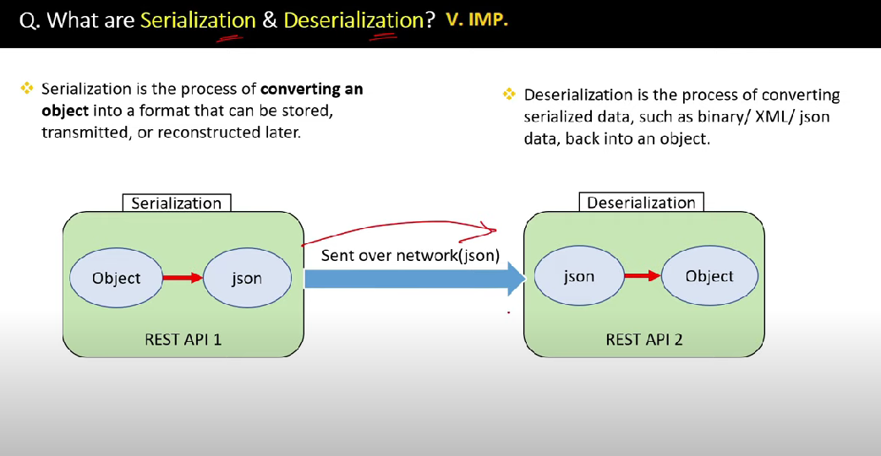

**Serialization Use Cases**:

* **Saving state**: Storing the state of an application or user session for later retrieval.
* **Data transmission**: Sending complex data structures over a network (e.g., in web APIs).
* **Caching**: Storing data in a cache to improve performance.
* **Interoperability**: Converting data into a standardized format (like JSON or XML) for use in different systems or languages.

**Deserialization Use Cases**:

* **Loading state**: Restoring an application or user session from a saved state.
* **Receiving data**: Reading complex data structures from a network response or file.
* **Reconstructing objects**: Creating objects from data stored in a database or external storage.
* **Interpreting data**: Transforming received data into usable formats in an application

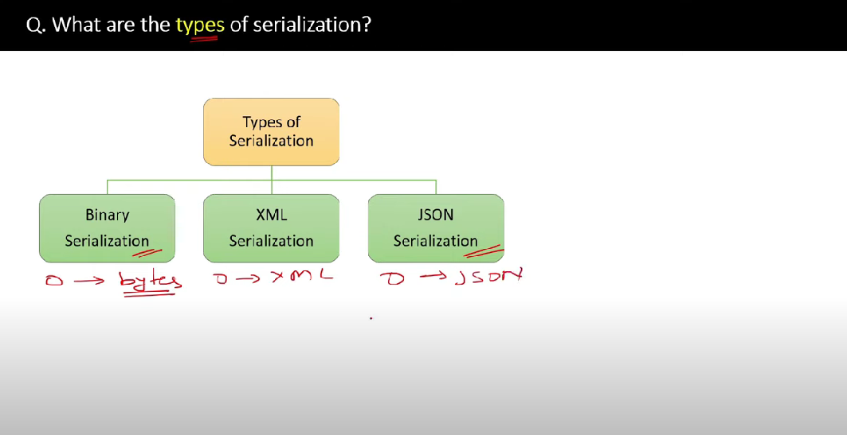

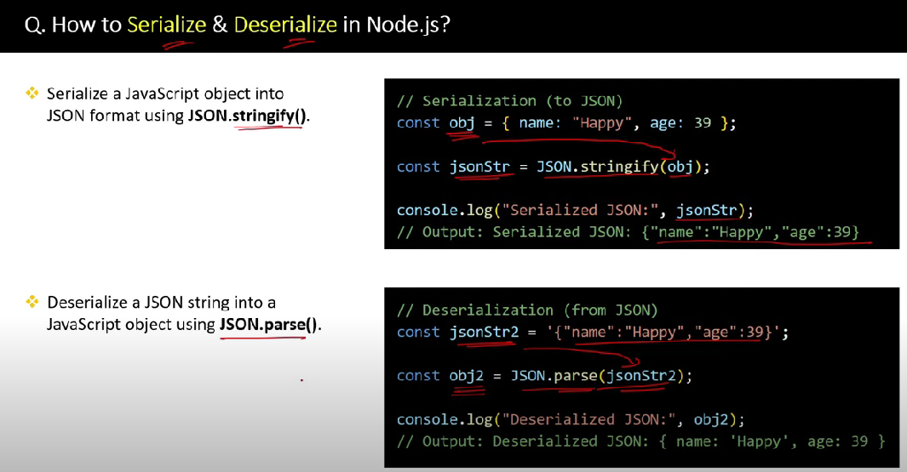

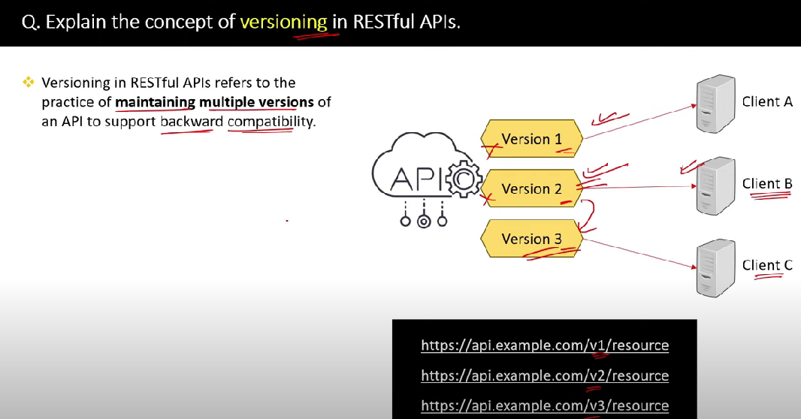

**What is an API?**

An API, or Application Programming Interface, is a set of rules and protocols that allows different software applications to communicate with each other.

It defines the methods and data formats that applications can use to request and exchange information.

**Key Points about APIs:**

1. **Interface**: APIs act as an interface between different software systems, enabling them to work together without needing to know the details of each other’s implementation.
2. **Types**:
   * **Web APIs**: Used over the internet, often following REST (Representational State Transfer) or SOAP (Simple Object Access Protocol) protocols.
   * **Library or Framework APIs**: Allow developers to use predefined functions and methods in libraries or frameworks (e.g., the Java API).
   * **Operating System APIs**: Enable applications to interact with the operating system (e.g., Windows API).

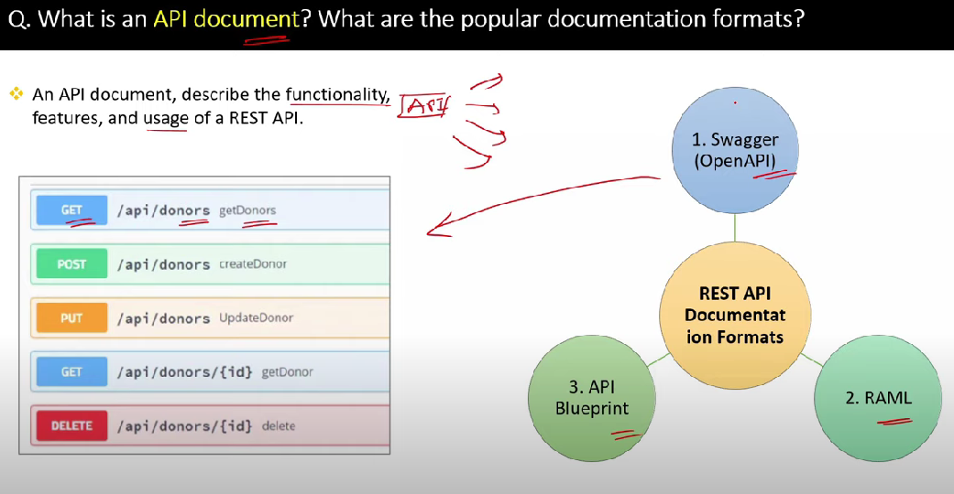

OR

API documentation is a comprehensive resource that provides information about how to effectively use an API (Application Programming Interface).

It serves as a guide for developers and users to understand the functionality, endpoints, parameters, and data formats of the API.

Well-structured API documentation is essential for promoting the use of an API and ensuring that developers can easily integrate it into their applications.

**Tools for API Documentation**

Several tools and platforms can help create and manage API documentation, including:

* **Swagger/OpenAPI**: A framework for API design and documentation that allows you to describe your API in a standard format.
* **Postman**: A popular tool for API development that also provides features for documenting APIs.
* **Redoc**: A tool to generate interactive API documentation from OpenAPI specifications.
* **GitHub Pages**: Can be used to host static API documentation.

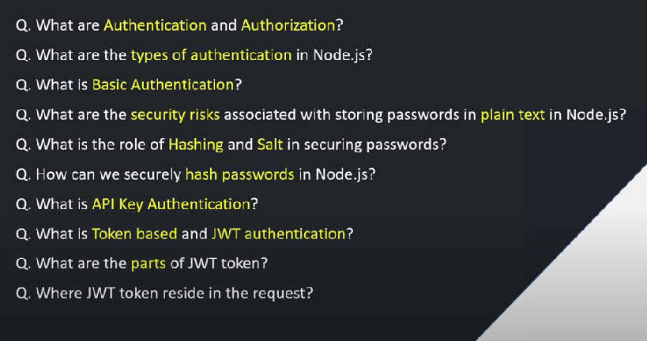

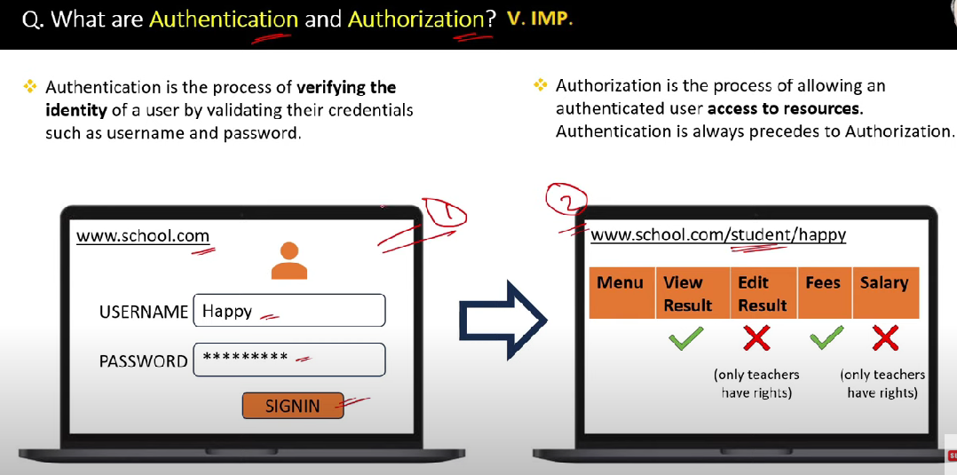

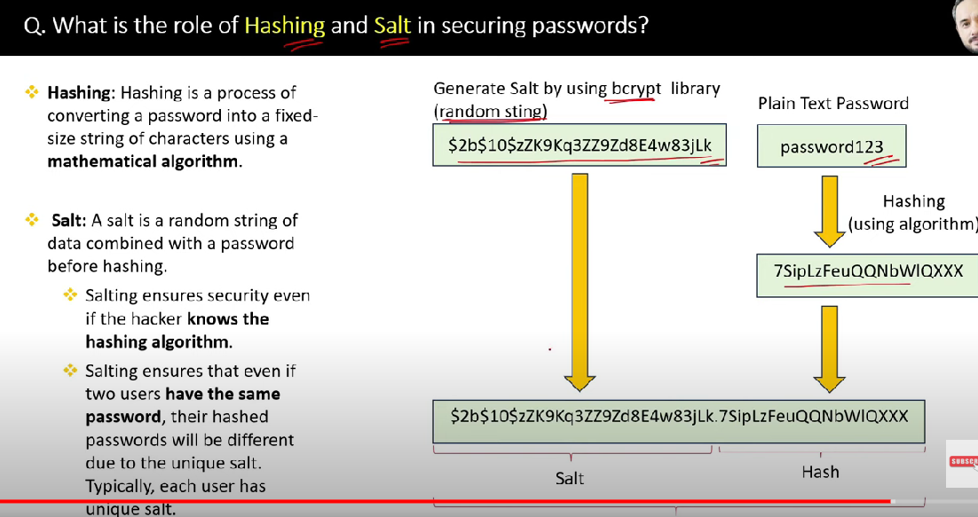

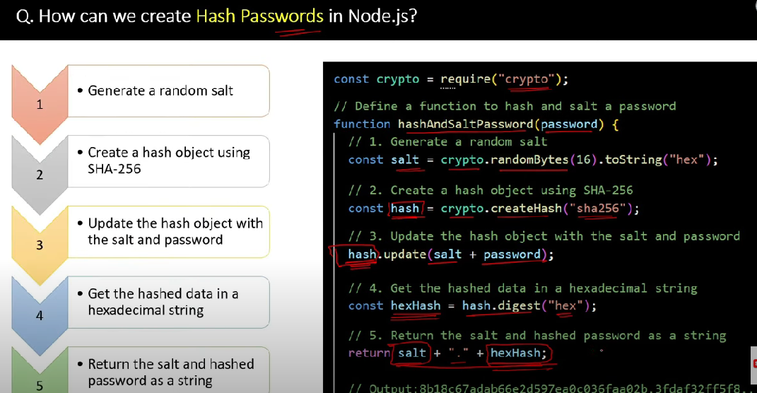

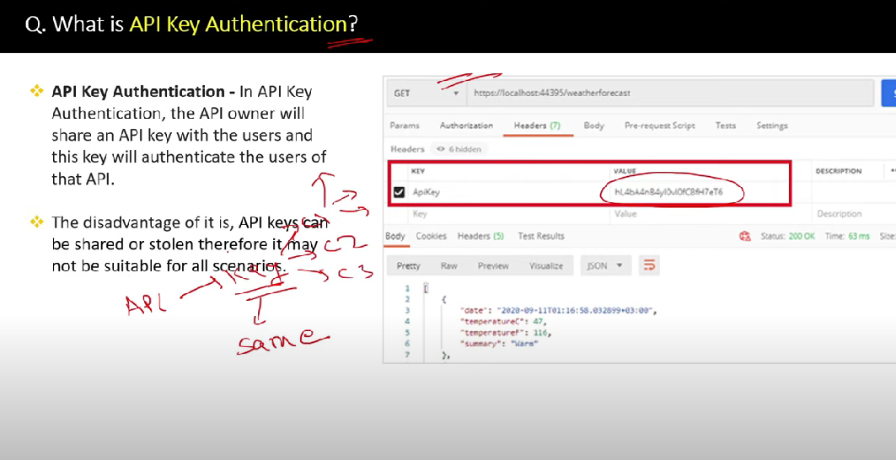

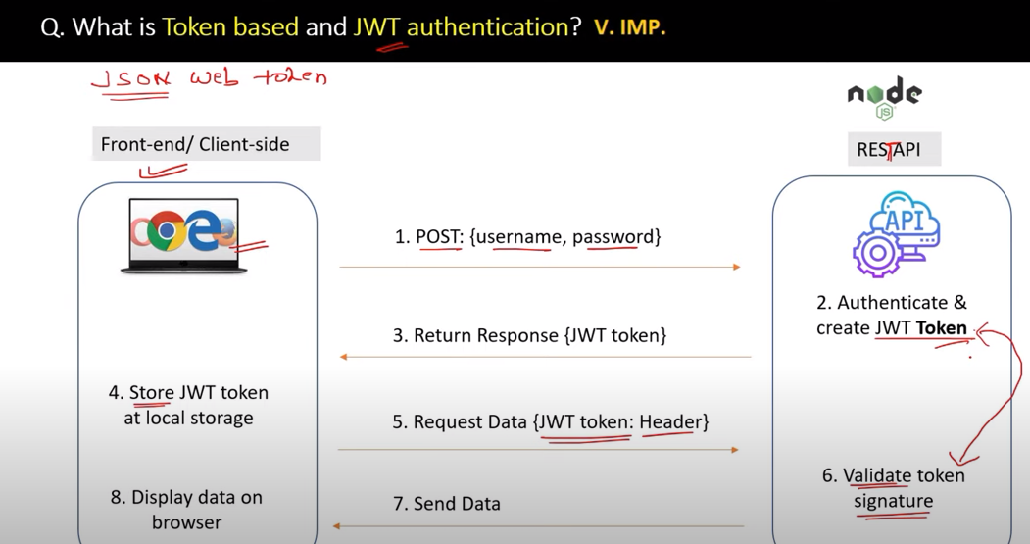

**A JSON Web Token (JWT) consists of three main parts:**

**1. Header**

The header is the first part of the JWT token.

It contains information about the token, such as the algorithm used to sign the token (e.g., HMAC SHA256 or RSA).

The header is Base64Url encoded.

Example:

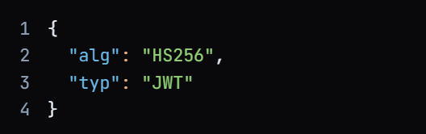

**2. Payload (Claims)**

The payload, also known as claims, is the second part of the JWT token.

It contains the actual data that the token is intended to convey, such as the user's identity, permissions, or other relevant information.

The payload is also Base64Url encoded.

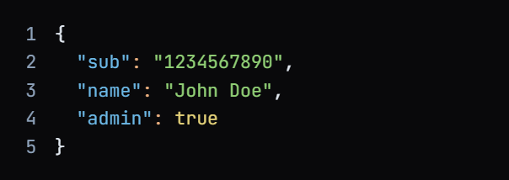

**3. Signature**

The signature is the third part of the JWT token.

The signature is used to verify that the token wasn’t altered. It is created by encoding the header and payload using Base64Url, then signing it using a secret key:

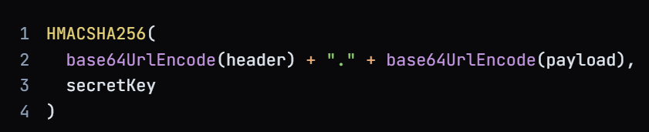

**JWT Authentication Workflow in Node.js**

**🧑‍💻 Client-Side (Front-End)**

1. **User Login Request**  
   The user submits a POST request with credentials (username, password) to the server.
2. **Server Authentication**  
   The server verifies the credentials against the database.
3. **JWT Token Generation**  
   If valid, the server generates a **JWT token** using a secret key or private key (for RS256).
4. **Token Response**  
   The server sends the JWT token back to the client in the response body or as a cookie.
5. **Token Storage**  
   The client stores the token securely:
   * In **localStorage** (for SPAs)
   * In **HTTP-only cookies** (for better security against XSS)
6. **Authenticated API Request**  
   For protected routes, the client sends the token in the Authorization header:
7. Authorization: Bearer <JWT>

**🛠️ Server-Side (Node.js API)**

1. **Token Extraction**  
   Middleware extracts the token from the request header or cookie.
2. **Token Verification**  
   The server verifies the token using the secret or public key:
   * Checks signature
   * Validates expiration (exp)
   * Decodes payload
3. **Access Granted or Denied**
   * If valid: request proceeds to the protected route.
   * If invalid/expired: server returns 401 Unauthorized.
4. **Optional: Role-Based Access Control (RBAC)**  
   The server can check user roles/permissions from the token payload to allow or deny access to specific resources.
5. **Token Refresh (Optional)**  
   If using short-lived access tokens, a **refresh token** mechanism can be implemented to issue new tokens without requiring re-login.

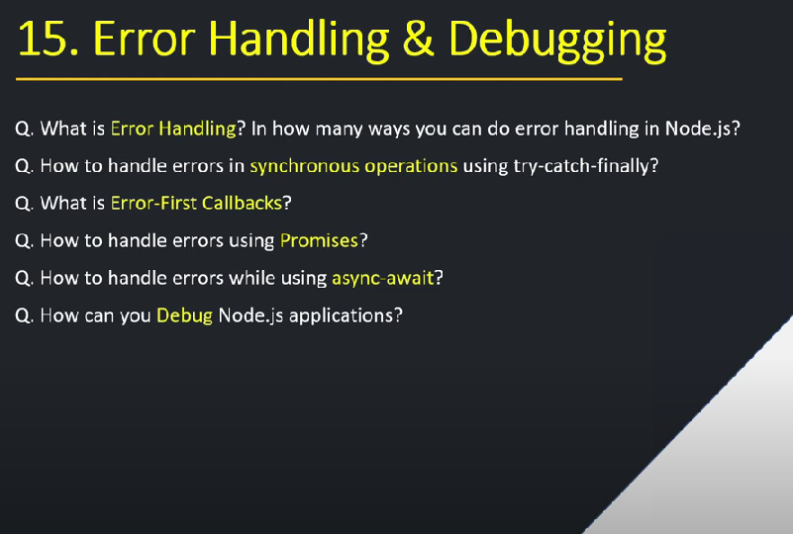

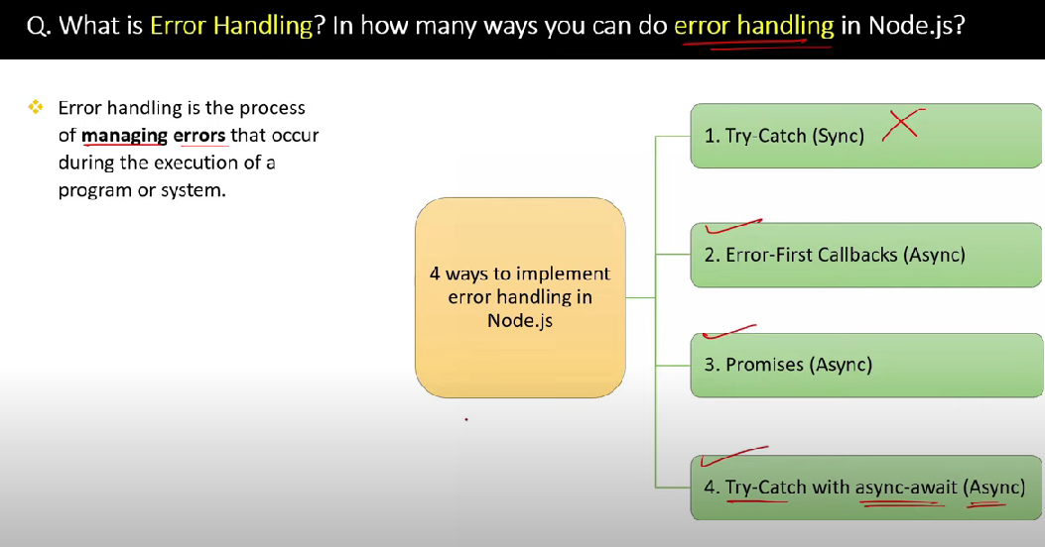

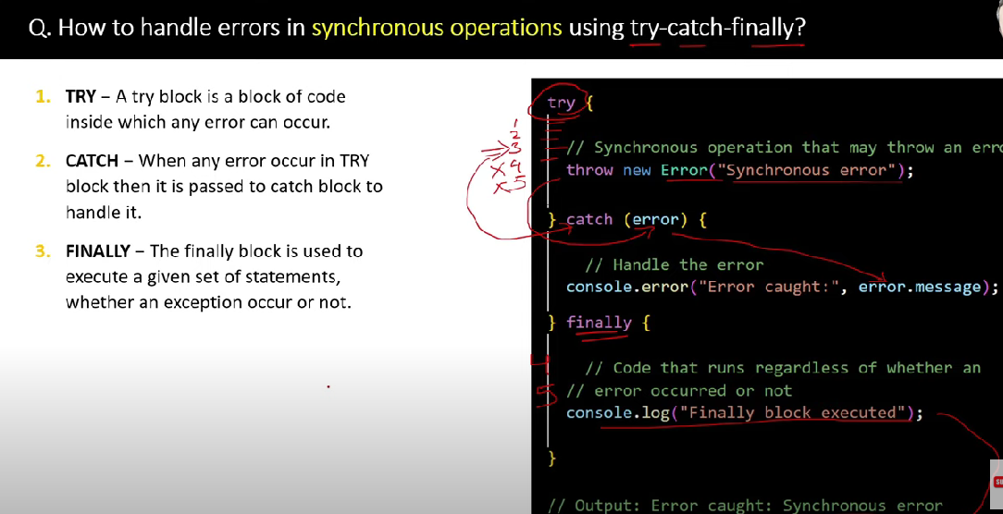

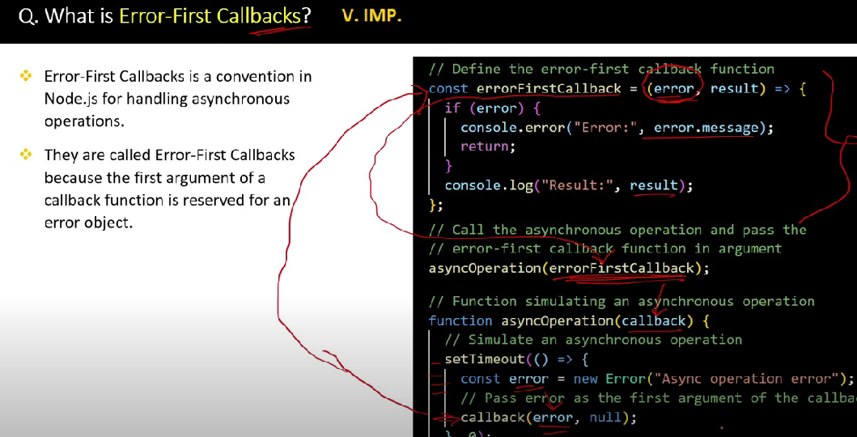

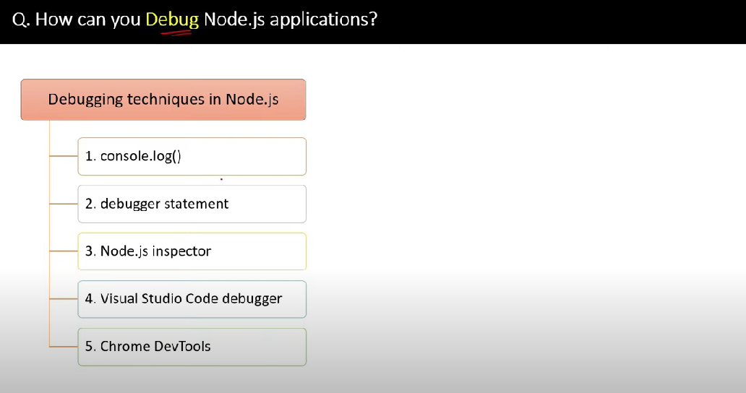

**Extra Knowledge**

NodeMailer

• **Port 25**: Typically not used for client-to-server communication due to spam issues.

• **Port 465**: Used for SMTP over SSL/TLS but is somewhat deprecated.

• **Port 587**: Recommended for SMTP with STARTTLS for secure email submission.

Important FO Migration

Sometimes the type of the data-time column get change so check it in new database.